**Moodle LTI Integration Guide**

There are two ways to create a Collaborate session within Moodle this document will provide instructions on using the Collaborate Ultra LTI.

To view the differences between each option please see the **Collaborate Moodle Plugin vs LTI connection** in the Selected Moodle Feature Comparisons Grids in Staff Moodle Help Course.

## Contents

Adding the Collaborate LTI to your Moodle course 2

Creating a Collaborate session in your Moodle course 4

Editing your Collaborate session 7

Entering your Collaborate session 8

Changing the participant communication settings in session. 9

Adding a Teacher on your course as a moderator to your Collaborate activity 9

Adding a guest to your Collaborate session 10

Promoting a Participant to a Moderator or Presenter within Collaborate Ultra 11

Recording your Collaborate session 12

Accessing your session recording 13

Captions on a recording 14

Download text chat from recording 15

Editing the name of your recording and access to recording 16

Deleting your Collaborate session recording 17

# Adding the Collaborate LTI to your Moodle course

1. Edit the course by clicking the **Edit mode** toggle switch at the top right corner of the course page. 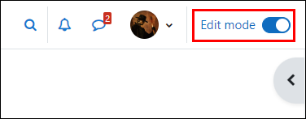
2. Go to the topic area you wish to add **Collaborate Ultra** to and click on the **Add an activity or resource.** 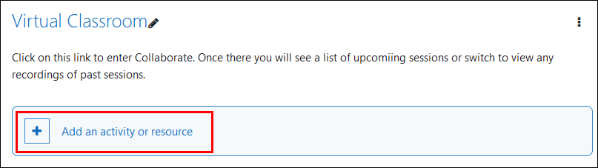
3. The **Add an activity or resource** dialogue boxwill be displayed. 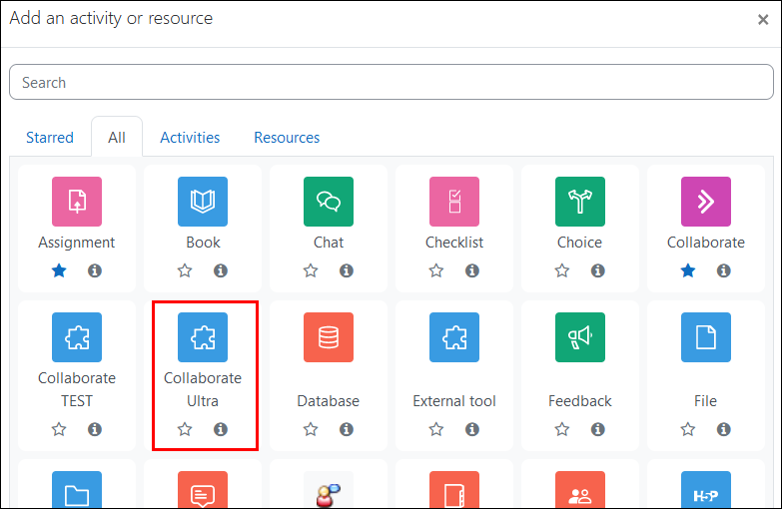

1. Click on the tile for **Collaborate Ultra**
2. A screen will appear asking for the activity name. It is recommend for the **Activity name** to be **Collaborate Ultra.** 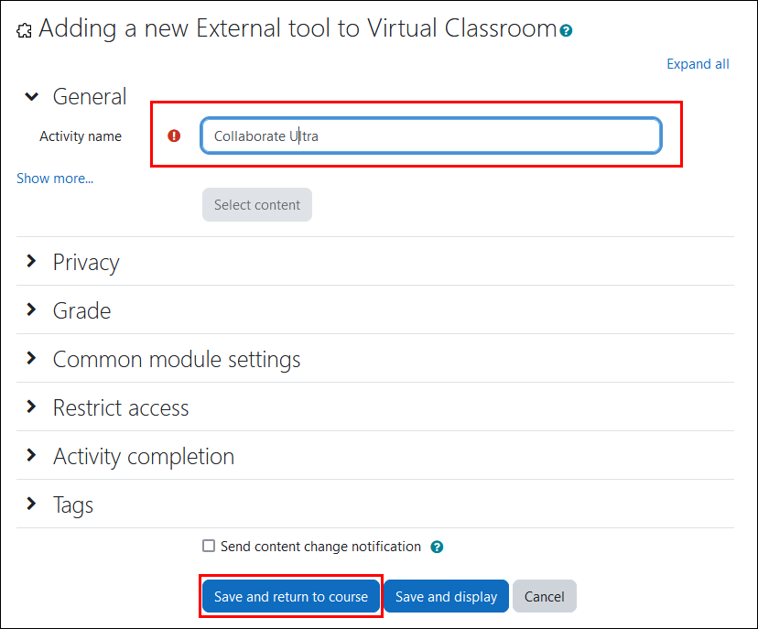
3. Click on **Save and Return to course** where you will find a link to your Collaborate Ultra activity in the topic.   
   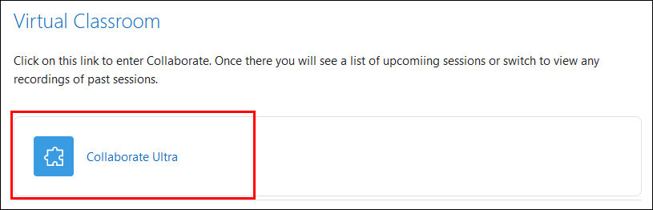

The LTI link has been successfully added to the Moodle course and now you will need to create the Collaborate Ultra sessions for the semester.

# Creating a Collaborate session in your Moodle course

1. Click on the link to the Collaborate Ultra activity which you’ve added to the course.
2. This screen will appear which will hold all the Collaborate sessions created as well as the recordings. Click on **Create Session.** 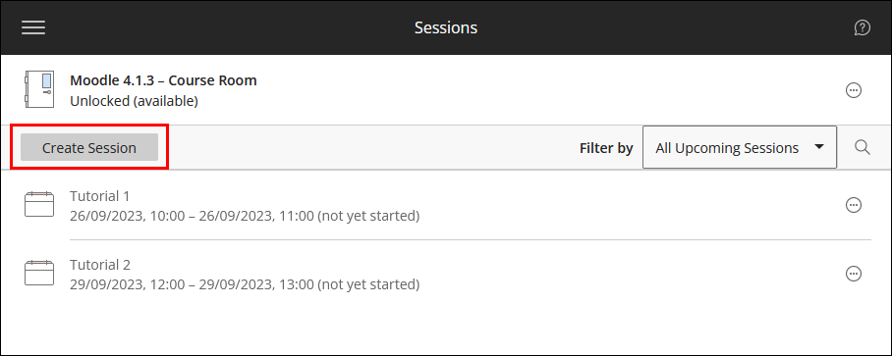

**Tip**: Above the create session button is the **Course Room.** This is a Collaborate session created automatically for each Moodle course and is always open. If you do not want to use this space then select the icon with three dots on the far right and select Lock Course Room. Locking it will make the room unavailable for students to join.

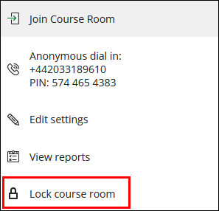

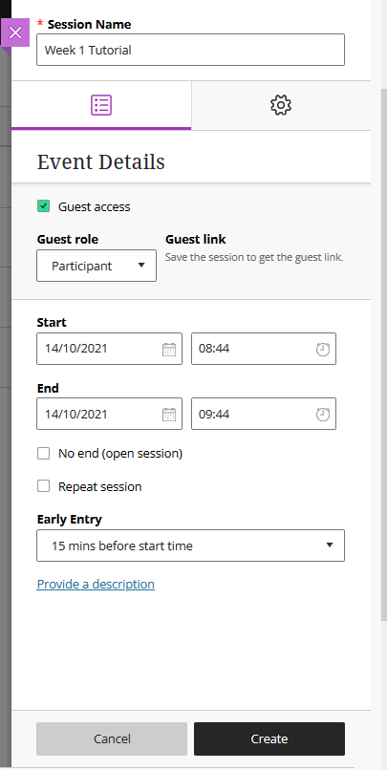

1. In the **Session Name** text box type an appropriate name that will be meaningful to the students for this event. “Week 1 Tutorial”, for example.
2. Tick **Guest access** if you require users external to Moodle and the University to join the session. You can change the **Guest Role** to Presenters, Moderators or Participants. The Guest URL will appear once you save the session.
3. **Set the date and time** the session starts and ends. You can choose to keep a session open or repeat.
4. **Early Session Entry** allows participants of the session access to the event up to 60 minutes beforehand.
5. Type a **detailed description** of the meeting. This helps students prepare for the session.

8. Click on the Session Settings tab at the top of the form:

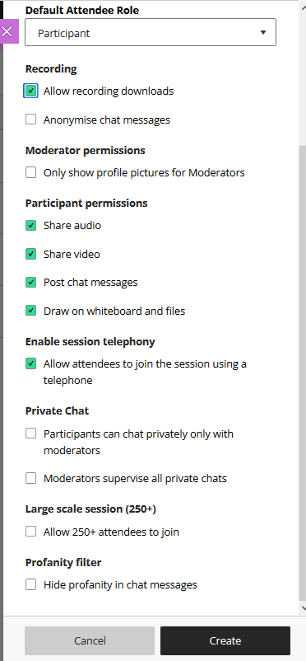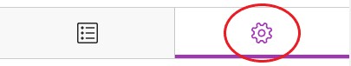

9. **Session Settings**. Here you can decide:

1. **Default Attendee Role** for students entering the session.
2. **Recording.** If a student can download the recording or if the chat messages are anonymised in the recording.
3. **Moderator permissions**. Only show profile picture for Moderators.
4. **Participant permissions**. If a participant can share audio, video, post chat messages or use editing tools.
5. **Enable session telephony**. Allow users to join via telephone.
6. **Private Chat**. Select if participants can only chat privately with the moderator. Moderator can supervise private chats.
7. **Large scale session (250+)**. Allows 250+ attendees to join the session with up to 500 attendees.
8. **Profanity filter.** This is primarily intended for primary and secondary school use, please see [more information](https://www.class.com/support/collaborate/moderator/moderate-sessions/chat/) before you choose this option.

10. Click **Create**

11. The Session will now appear in the **All Upcoming Sessions** list:

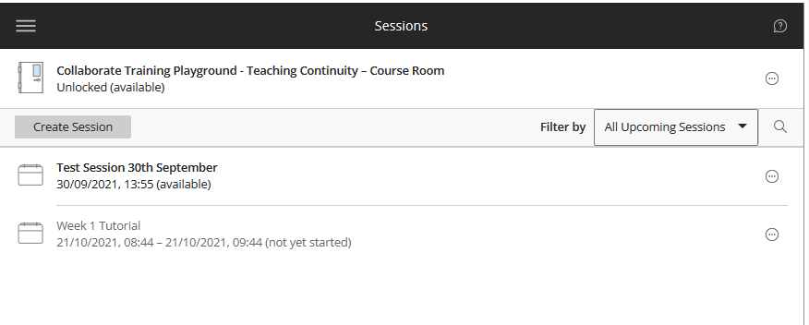

# Editing your Collaborate session

If you ever need to edit your Collaborate session please follow these instructions.

1. Choose the **Session Options** (at far right side of menu) and **Edit**

**Settings** under the Collaborate Session you created (see below).

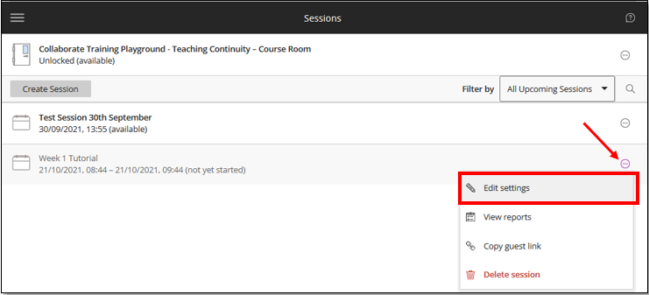

1. This will bring you back to the same menu where you created the session (see pages 5 & 6). Make your changes and click **Save.**

# Entering your Collaborate session

1. Navigate to your course. Click on the **Collaborate Ultra LTI** that has been added to your course (see pages 2 & 3).



1. Click on the **session name / title** and then **Join Session.** This will automatically open Collaborate Ultra in a new tab in your browser **(use Google Chrome for the best experience)**.

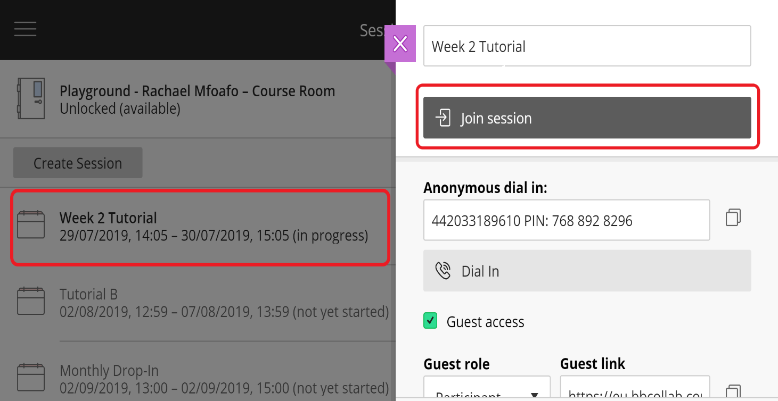

# Changing the participant communication settings in session.

1. Enter your Collaborate room.
2. Click on the **purple tab** in the bottom right hand corner of the screen.
3. In the side panel that appears, click on the gear icon (**My Settings**).
4. Click on **Session Settings**.
5. You will now see **Gallery View** and **Participants Permissions**. Click on the check boxes for the communication options you want to make available to the students.

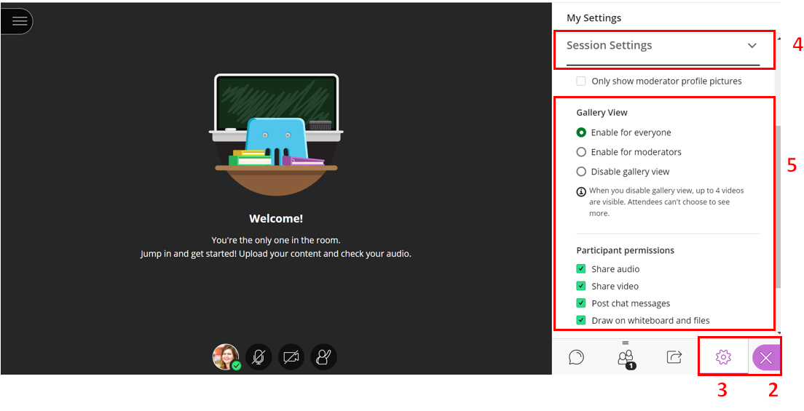

# Adding a Teacher on your course as a moderator to your Collaborate activity

1. All course participants can access this Collaborate session via the course.
2. **Students** will join the session as a **Participant** in Collaborate.
3. **All other roles** (teacher, non-editing teacher, programme admin, course secretary, course editor, course owner) will join the session as a **Moderator** in Collaborate.

# Adding a guest to your Collaborate session

1. In the collaborate session settings you have the option to check the box ‘**Guest Access**’ and select the Collaborate guest role from Presenter, Participant or Moderator. This will generate a “guest link” which you can send to people outside of your course (such as guest speakers) to let them join the session.

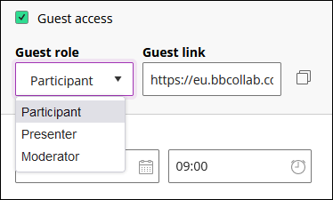

1. Copy the Collaborate guest link and send to external users to join the session.

**Tip**: Session security - be mindful of who you share the guest link with. For example, if sharing with a guest lecturer only share with that person and advise against re-sharing.

# Promoting a Participant to a Moderator or Presenter within Collaborate Ultra

1. Join the Collaborate session via the course.
2. Open the **Collaborate Panel** and open the **Attendees** list.
3. Click on the **Moderator controls** icon next to the participants name
4. Select **Make moderator, Make presenter or Make captioner.** You also have the option to remove an attendee from the session in this panel.

# Recording your Collaborate session

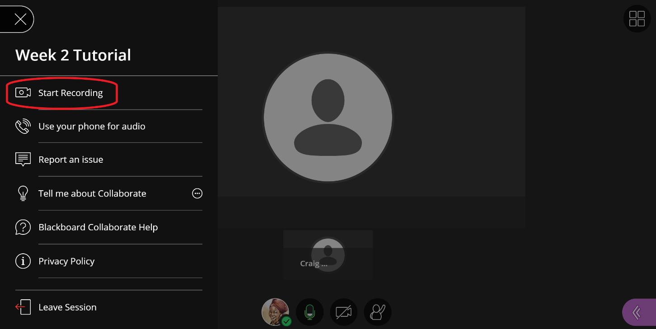

1. From within your Collaborate Session click on **Open Session Menu** at the top left hand corner of the screen (the icon looks like this ).
2. Click on **Start Recording** (highlighted in the image above) to start recording your session.
3. To stop recording click on the **Stop Recording** button. To start recording again you can click on **Start** **Recording**. **NOTE:** If you stop and start recording several times during a session, the recordings will not be aggregated into a single recording for the session.
4. Exit the Collaborate session by closing the window.

# Accessing your session recording

1. Navigate to your course in Moodle.
2. Click onthe link to the **Collaborate Ultra LTI** that you previously created.
3. 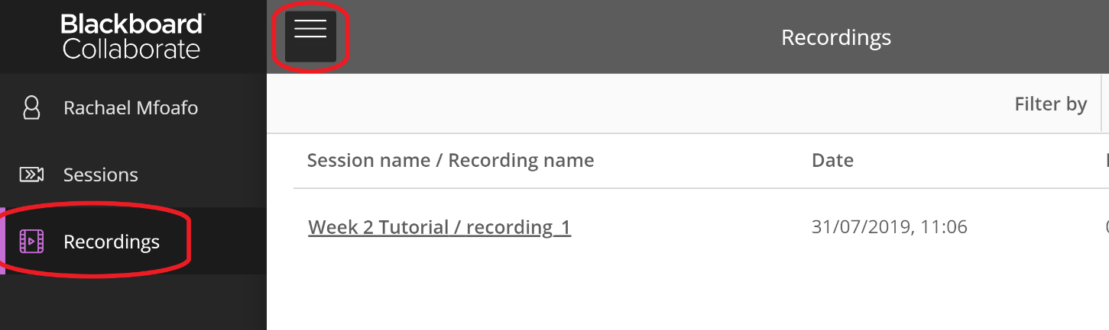Click on the **Menu** icon(far left)and select **Recordings**. You can toggle between sessions and recordings by clicking on the Menu button.
4. Click on the Recording options icon at the far left for the appropriate recording.
5. You can either view the recording in browser by selecting **Watch Now** or **Download** the recording as an MP4 file via the download button or copy the recording URL via **Copy Link.**

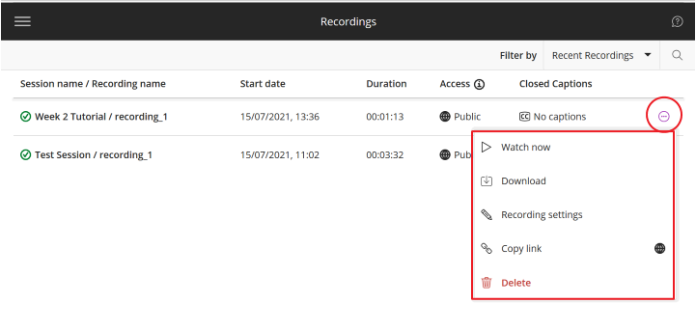

**Please Note:**

If your students do not see the download button go back to edit session (see page 7) and choose **Allow recording downloads** (see page 6). You will need to reset the start time to the present date and time for it to save.

**Please Note:**

The best place to store your Collaborate Ultra recordings long term is [Media Hopper](https://www.ed.ac.uk/information-services/learning-technology/media-hopper-create)[,](http://www.ed.ac.uk/information-services/learning-technology/media-hopper/introduction) which is the University of Edinburgh Media Management service. You can easily upload the MP4 files into your Media Hopper Channel and share it within your course.

[Media Hopper Guides and Support](https://www.ed.ac.uk/information-services/learning-technology/media-hopper-create/help-and-support)

[Media Hopper Portal](https://media.ed.ac.uk/)

# Captions on a recording

Collaborate can automatically generate captions and a transcript of your session recordings.

**Note**: Auto-captioning is only available for recorded sessions; auto-captioning in real time is not available in Collaborate. Also note that auto-captioning is currently only available for recordings in English.

1. In the Recordings area, click on the Recording options icon (ellipsis in a circle) for the recording that you would like to caption. Select **Recording settings**.
2. In the Recording Settings panel, toggle on **Enable captions**, if not already selected. Then click **Create auto-caption**.  
   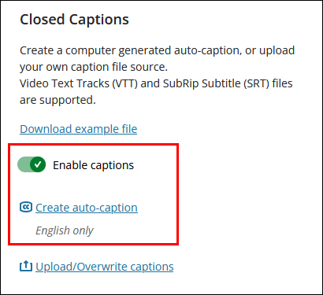  
   It may take time for the auto-captions to generate. You can leave this screen and come back later to view and share them. After the captions are created, you’ll see that captions are available from the recording list. The captions will also immediately appear in the recording player for anyone who has access to the recording.
3. To improve or edit the auto-generated captions, click **Download captions** and open the downloaded .vtt file in a plain-text editor, such as Notepad on Windows, or Textedit on a Mac. When you have finished editing the captions, save the file, click **Upload/Overwrite captions** and select the .vtt file from the location you saved it.  
   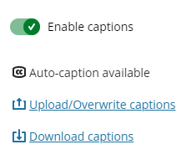

# Download text chat from recording

1. In recordings select **Watch Now** (it will open the recording in a new tab within your browser)
2. Click on **Open Recording Menu** which is at the top left hand corner of the screen (the icon looks like this ).

1. Click on **Download Chat.**

# Editing the name of your recording and access to recording

1. In the Recordings area, click on the Recording options icon (ellipsis in a circle). Select **Recording settings**

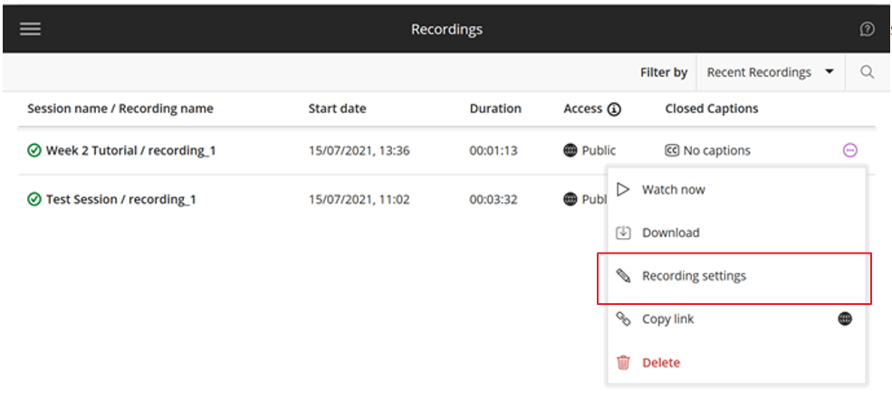

1. Edit the recording name.
2. Additionally, you can choose whether you’d like the recording available for the **course members** (students and other enrolled on the course) or **public** (you can share the recording link with people outside the course).   
   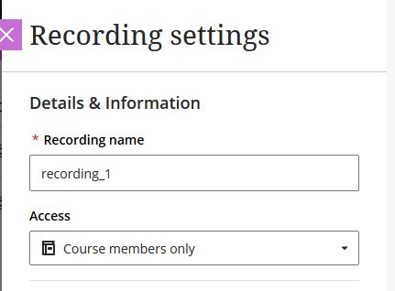
3. Click on **Save** when finished.

# Deleting your Collaborate session recording

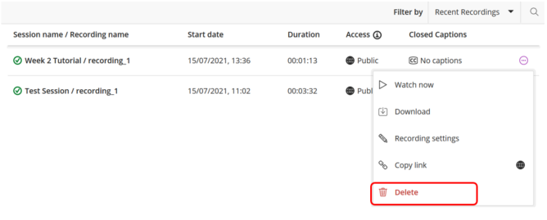In the Recordings area, click on the Recording options icon (ellipsis in a circle). Select **Delete** to delete the session. A dialog box will then pop up asking you to confirm the deletion of the session.