Assistive Technology loans for Staff – Keyboards
To request this document in an alternative format e.g. large print, Braille et. cetera please contact Jed Bajai via email at Jed.Bajai@ed.ac.uk

Keyboards | Make and Model | Equipment Description | Serial Number
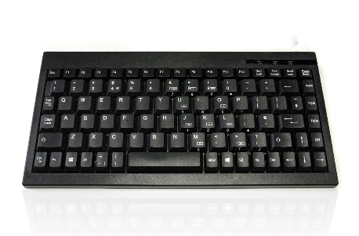 | Accuratus mini keyboard | A USB wired keyboard for full control of your computer, laptop, tablet. Mini keyboard layout with full size keycaps for comfortable typing - compatible with Windows and Android. | S/N - 1709000074
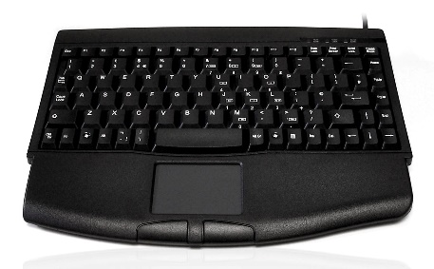 | Accuratus 540 Mini + touchpad + wrist rest keyboard (white on black) | A Bluetooth touchpad keyboard - all in one wireless keyboard and mouse touchpad with wrist rest keyboard for full control of your computer, laptop, tablet. Mini keyboard layout with full size keycaps for comfortable typing - compatible with Windows and Android. | S/N = 1604002064
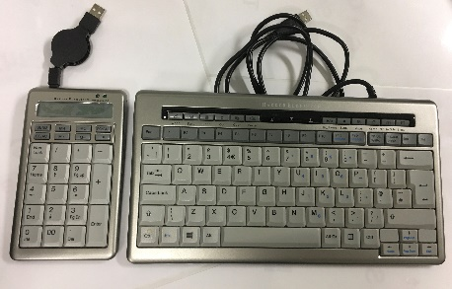 | Bakker Elkhuizen S-Board 840 compact (black on grey) | A compact ergonomic mini keyboard for use with laptop and desktop PCs.  It has conveniently placed navigation keys, integrated numeric pad, a larger enter key, and two USB ports.  It has a light key touch. The keyboard of the 840 has non-reflective black on grey keys. Comes with separate Number Pad. | 1 Keyboard S/N=1711183207 1 Number Pad S/N=1712176693
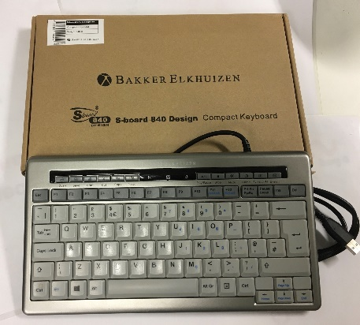 | Bakker Elkhuizen S-Board 840 compact (black on grey) | A compact ergonomic mini keyboard for use with laptop and desktop PCs.  It has conveniently placed navigation keys, integrated numeric pad, a larger enter key, and two USB ports.  It has a light key touch. The keyboard of the 840 has non-reflective black on grey keys. | S/N=1804185515
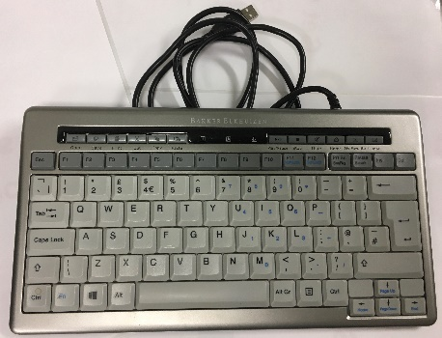 | Bakker Elkhuizen S-Board 840 compact (black on grey) | A compact ergonomic mini keyboard for use with laptop and desktop PCs.  It has conveniently placed navigation keys, integrated numeric pad, a larger enter key, and two USB ports.  It has a light key touch. The keyboard of the 840 has non-reflective black on grey keys. | S/N=1904189243
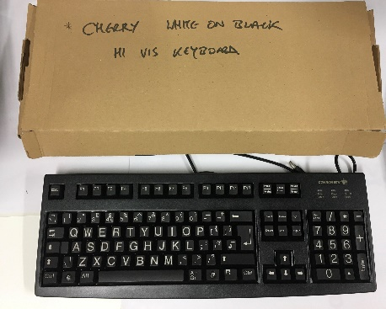 | Cherry High Visibility  G84 4100 (black) | Compact and reliable keyboard, an ideal solution for users with limited available space. Designed to be used for a range of portable systems. Individual keys with gold Crosspoint contacts with lightweight design. | S/N=C-002531-Z06
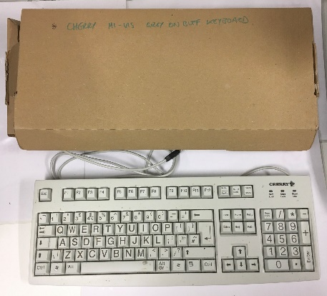 | Cherry High Visibility  G84 4100 (white) | Compact and reliable keyboard, an ideal solution for users with limited available space. Designed to be used for a range of portable systems. Individual keys with gold Crosspoint contacts with lightweight design. | S/N=G-0000265-4Y31
 | Cherry High Visibility  G84 4100 (black) | Compact and reliable keyboard, an ideal solution for users with limited available space. Designed to be used for a range of portable systems. Individual keys with gold Crosspoint contacts with lightweight design. | S/N=G-0003174-424
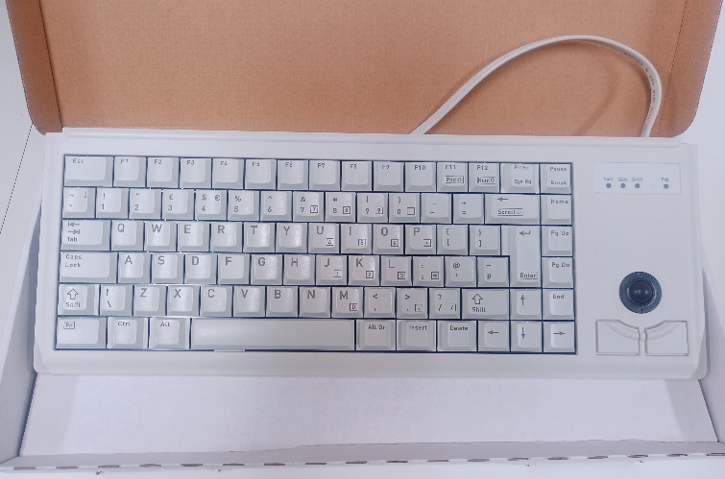 | Cherry g84-4400 Keyboard | This ultra-flat compact keyboard with built-in trackball is the perfect solution, if you need a pointing device but space restrictions prevent you from using an extra mouse  Individual keys with Gold Crosspoint contacts (ML technology).  High level of reliability and unique precision confirmation feeling. Minimal space requirements / Lightweight. | S/N=G84-4400LPBGB-0
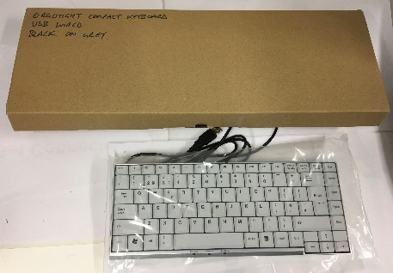 | Ergotight Soft Touch non-reflective compact keyboard (black on grey) x3 | The Ergotight keyboard has been designed to have a small footprint - with full size keys. The soft touch makes this an ideal solution for users wanting to reduce shoulder movement and keep the mouse close into the working area. The non-reflective surface makes this a good choice for users who need to avoid glare and for environment with overheard fluorescent lighting.  This lightweight version is an ideal solution for laptop users. | S/N = 120202657
 | Ergotight Soft Touch non-reflective compact keyboard (black on grey) | The Ergotight keyboard has been designed to have the smallest footprint possible for a compact keyboard  with full size keys. The soft touch makes this an ideal solution for users wanting to reduce shoulder movement and keep the mouse close into the working area. The non-reflective surface makes this a good choice for users who need to avoid glare and for environment with overheard fluorescent lighting.  This lightweight version is an ideal solution for laptop users. | S/N=120202995
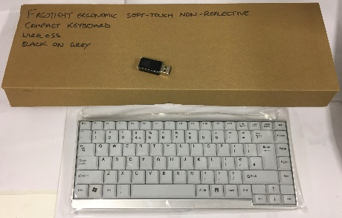 | Ergotight Soft Touch non-reflective compact keyboard (black on grey) | The Ergotight keyboard has been designed to have the smallest footprint possible for a compact keyboard  with full size keys. The soft touch makes this an ideal solution for users wanting to reduce shoulder movement and keep the mouse close into the working area. The non-reflective surface makes this a good choice for users who need to avoid glare and for environment with overheard fluorescent lighting.  The lightweight wireless version is an ideal solution for laptop users. | S/N=120301796
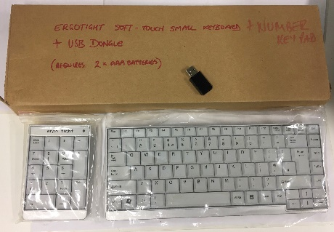 | Ergotight Soft-Touch compact keyboard (black on grey)  Ergotight Numberpad  (Packaged as a set, don't separate for loan) | The Ergotight keyboard has been designed to have the smallest footprint possible for a compact keyboard  with full size keys. The soft touch makes this an ideal solution for users wanting to reduce shoulder movement and keep the mouse close into the working area. The separate optional number-pad gives  flexibility to work either left or right handed. The non-reflective surface makes this a good choice for users  who need to avoid glare and for environment with overheard fluorescent lighting.  The lightweight wireless version is an ideal solution for laptop users. | S/N=070800049
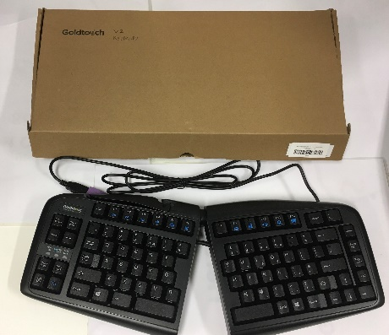 | Goldtouch V2 Adjustable Keyboard | The Goldtouch V2 Adjustable Comfort Keyboard is designed specifically with the individual in mind.  Prevent carpal tunnel with the perfect fit: This keyboard adjusts from 0-30° on the horizontal plane to properly straighten your wrists and provides 0-30° of vertical tenting to help you achieve a more natural and comfortable position.  Allows for dynamic positioning: Two feet on the back of the keyboard create a negative sloping angle, positioning your wrists in a neutral or downward position rather than tilted upward.  Soft key touch, low activation force, and full key travel distance: Provides keying comfort and reduces risk of “bottoming out” when typing. | Model Number=SK-2730
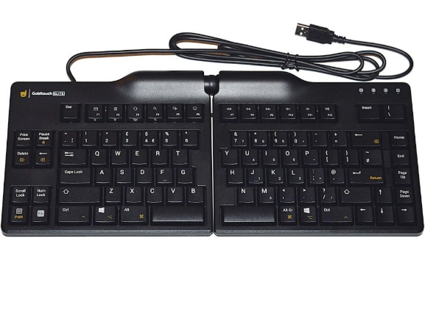 | GoldTouch Elite PS2 Keyboard  # Replaced the Microsoft Sculpt Keyboard - not returned by User. | The Goldtouch Elite is an ergonomic split keyboard for your desktop. This ergonomic split keyboard can be adjusted in its inclination angle between 0-30 degrees, and it is guaranteed that the keyboard remains very stable. For the optimal ergonomic usage, we recommend a split keyboard for people who type blindly in the ten-finger system. | S/N = 100136274
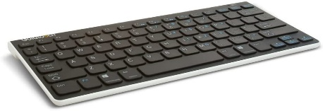 | Goldtouch Mini GTA-0033 Bluetooth wireless keyboard | The Goldtouch Bluetooth Mobile Mini Keyboard provides you the convenience of a lightweight and stylish wireless keyboard, anywhere you go, no matter what mobile device you use. The Bluetooth Mini Keyboard is great for quick typing tasks that don’t require a full sized keyboard, but allows users to avoid awkward touch screen typing or typing on tiny mobile device keypads.  Bluetooth Wireless Technology allows the keyboard to connect to PC’s, MacOS, Laptops, Tablets, iPhone’s, iPad’s & Internet connected TV. | Model=sk-9071
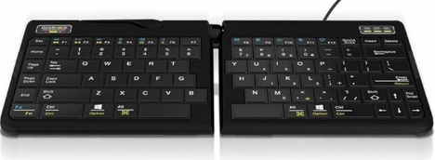 | Goldtouch Go2 Travel - Split - Adjustable Keyboard | GoldtouchGo!2 Mobile Keyboard, Portable Foldable Travel Keyboard Black. USB Wired.  Adjusts from 0º to 30º along the horizontal and vertical planes Scissor-switch system for fluid, silent keystrokes with tactile feedback Slim shape allows it to fit neatly within even the smallest spaces. | GTP0044UK-2220053400
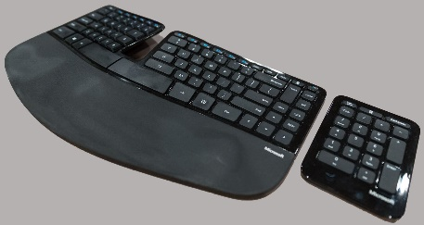 | Kinesis Freestyle2 Split Mini Keyboard | Accommodates a wide range of individuals from small to tall and body types in between, the Freestyle2 allows for maximum flexibility catering to each individual’s unique needs. Both modules are connected together by a flexible pivot tether allowing an infinite range of splay. Disconnecting the pivot tether allows up to 9 or 20 inches of complete separation of both left and right keying modules. Perfect for individual needs ranging from a narrow footprint to complete separation. This design greatly reduces and or/eliminates ulnar deviation.  The Freestyle2 utilizes a quiet, low-force, tactile membrane key switch with driverless hot keys for commonly used mouse actions. A vertical rib is located on the inside row of hot keys to provide tactile notification to the user.  The accompanying Freestyle2 Keypad matches the low-profile design of the Freestyle2 keyboard and utilizes the same low-force, quiet and tactile membrane key switch. | S/N=800PBUKAA2887
Keyboard | Logitech K400 media keyboard | N/A | S/N=5050914725990
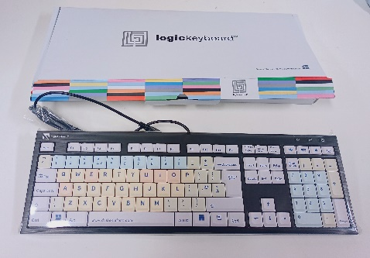 | LogicKeyboard | Colour-coded LogicKeyboard - the keyboard allows you to take advantage of software keyboard shortcuts.  Using keyboard shortcuts can reduce the repetitive motion associated with using a mouse, which can often lead to health hazards such as carpal tunnel syndrome. Ergonomic keyboards can help reduce your injury risk.  Low Profile chassis / silent keystrokes / USB wired | S/N=KP800HPUSAB8513
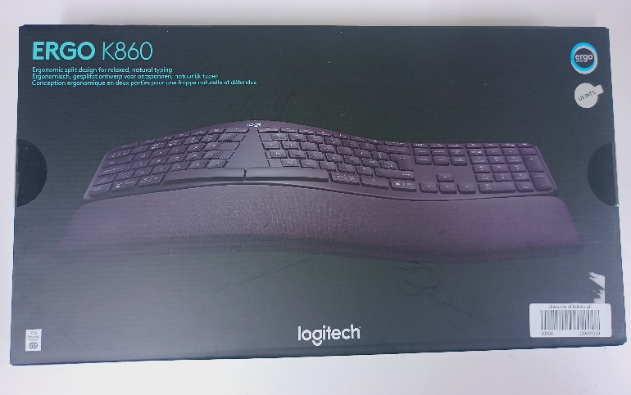 | Logitech Ergo K860 Keyboard | A split ergonomic keyboard designed for better posture, less strain, and more support.  Helping you type more naturally with a curved, split keyframe that improves typing posture. The sloping form reduces muscle strain on your wrists and forearms – keeping your hands and shoulders relaxed.  ERGO K860’s curved keyframe places your hands, wrists, fingers and forearms in a more natural posture | S/N = 2345SC801UM9
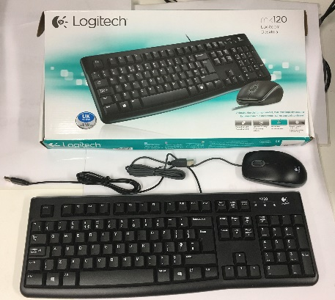 | Logitech MK120 desktop | This Keyboard has a low-profile, whisper-quiet keys and standard layout with full-size F-keys and number pad.  The slim keyboard is tough with a spill-resistant design, sturdy tilt legs and durable keys.  A comfortable and quiet typing experience thanks to the low-profile keys with full-size F-keys and number pad.  It has a thin profile that keeps your hands in a more comfortable, neutral position.  The bold, bright white characters make the keys easier to read — perfect for those with less-than-perfect vision.  You can extend the sturdy folding legs to increase the keyboard tilt by 8 degrees to address your personal ergonomic needs and it also has a curved space bar for greater comfort.  Comes with a precise, high-definition optical mouse to help you get around. | S/N - 1412MG018BK8
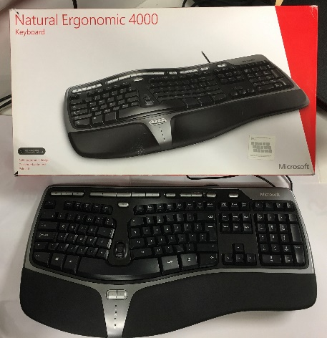 | Microsoft Natural Ergonomic 4000 | The Microsoft Ergo 4000 Keyboard has been designed to allow you to work in a more natural position. The new Gull Wing design features a 14-degree gable, a natural arc and a curved key bed - bringing the keys closer to your fingers to reduce reach and unnecessary motion, encouraging a more natural typing position.  It has an optional palm lift for a seven-degree reverse slope and a cushioned wrist rest that encourages better arm and wrist alignment. Its features include;  Ergonomic Split Key Design - Type in total comfort. Ergonomic design encourages natural wrist and arm alignment so you can work without discomfort. Integrated Palm Rest.  Zoom feature - Zoom in quickly and accurately with the intuitive Zoom feature MultiMedia Keys.  Customizable Hot Keys - Perform common tasks, like opening documents and replying to e-mail, with the touch of a button.  Improved Number Pad - Commonly used symbols such as equal sign, left and right parentheses and "Backspace” are in quick reach, just above the number pad. | 0135471210
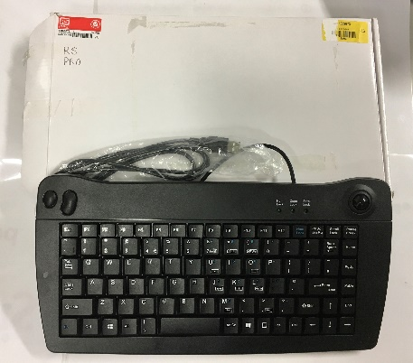 | RS PRO Mini trackball keyboard  (white on black) | The RS PRO 5010 is a compact Mini Optical Trackball Keyboard. With its trackball and mini key layout, it is an ideal keyboard for use in environments where space is limited.  Black case and key caps with white key legends.  Mini keyboard size and layout - compact and slim design.  High-resolution laser etched key legends for durability.  Integrated 200 dpi opto-mechanical trackball – offering an all in one keyboard and mouse solution.  Integrated left and right mouse buttons - left and right mouse buttons can be found on the top left corner.  Fold out feet to provide keypad tilt.  Designed for use with all versions of Microsoft Windows with USB support. | 5707795020514
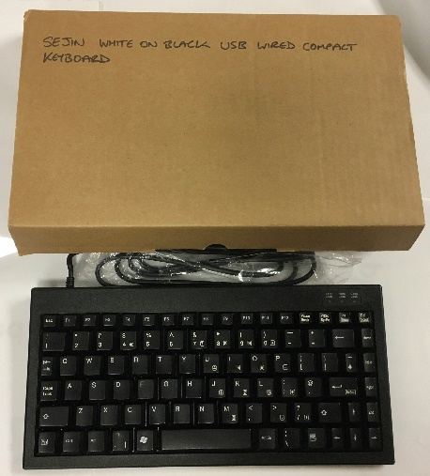 | Sejin compact keyboard (white on black) | Portable Mini Keyboard Compact and lightweight 86 key keyboard, ideal for portable applications and racked systems. Reduced space saving footprint. Full size key pitch with embedded numeric keypad - Quiet tactile feel.  High reliability membrane technology.  Adjustable tilt legs Non-skid rubber feet.  Keyboard Colour: Black/Ivory  Compatible with Microsoft Windows Series.
 | Sejin compact keyboard (white on black) | Portable Mini Keyboard Compact and lightweight 86 key keyboard, ideal for portable applications and racked systems. Reduced space saving footprint. Full size key pitch with embedded numeric keypad - Quiet tactile feel.  High reliability membrane technology.  Adjustable tilt legs Non-skid rubber feet.  Keyboard Colour: Black/Ivory  Compatible with Microsoft Windows Series | S/N - 1412MG018BK8
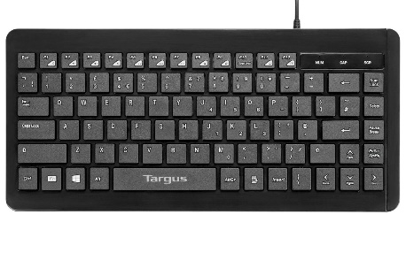 | Targus compact keyboard, white on black | Transportable: Lightweight and compact for maximum portability.  Plug and Play: Provides seamless desktop replacement for Notebook PC users.  Built-in multimedia shortcut keys: Pre-programmed shortcut keys enhance productivity.  The Compact USB Keyboard from Targus comes with standard-size keycaps but without the numeric keypad | S/N=7687604674745
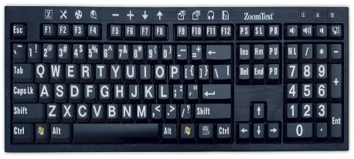 | ZoomText Hi-Vis large print white on black keyboard | Designed for anyone who struggles to see the lettering on their keyboard, the ZoomText Large-Print Keyboard makes typing faster and easier. Each key and button label is easy to see, even in low light, thanks to its 36-point text and choice of high-contrast colour scheme.  The ZoomText Large-Print Keyboard also provides quick access to ZoomText features. The F1 through F12 keys perform double duty. When you press and hold a function key, its assigned ZoomText command is triggered. The commands allow you to instantly start ZoomText, change magnification levels, toggle screen enhancements, launch AppReader and DocReader, and more, all without having to memorize hotkeys. | M/N=0625-0095-73381

