Booking Accessible Study Rooms
To request this document in an alternative format, please contact Viki Galt by email viki.galt@ed.ac.uk

Overview
This document shows how to book an accessible study room on a desktop and mobile device, how to cancel or update a booking, and adds other useful information.

Booking an Accessible Study Room on a computer

Finding a link to the room booking system
- Log in to MyEd
- Select ‘Studies’ tab on the top-left corner of the page
- Select ‘Book a study space’
- Select ‘Booker – accessible rooms’ (a link will open in a new tab)
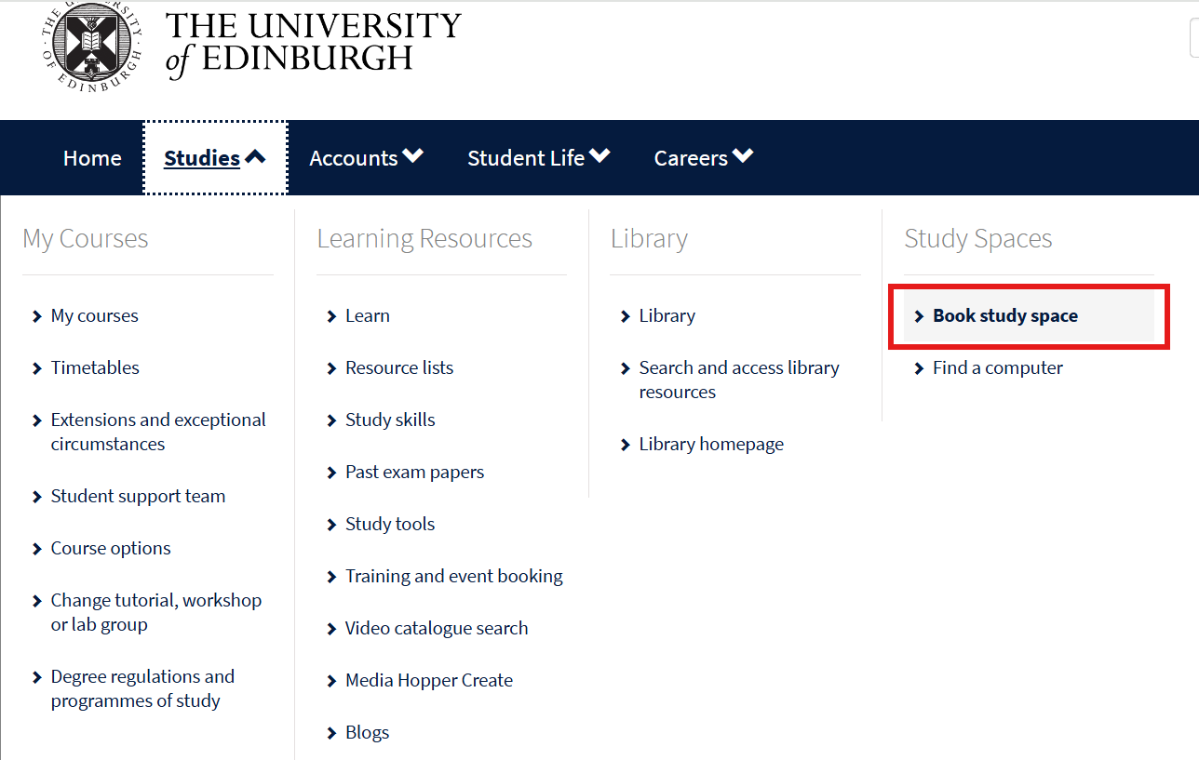
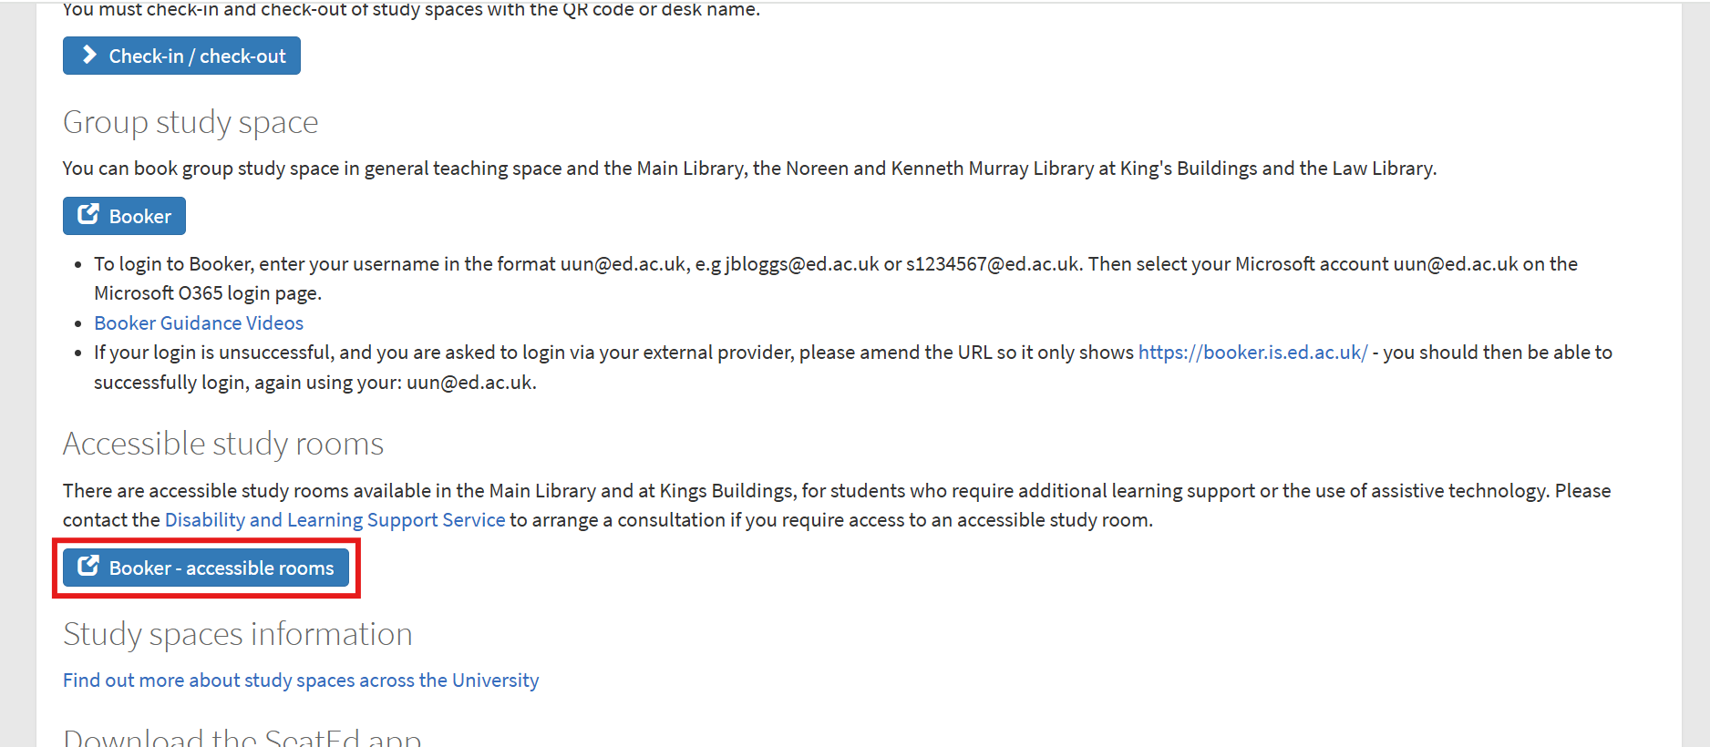

Logging in
Once the Booker system opens, enter the username (your University email, such as s0000000@ed.ac.uk) and password (your usual University login password) to log in into the system
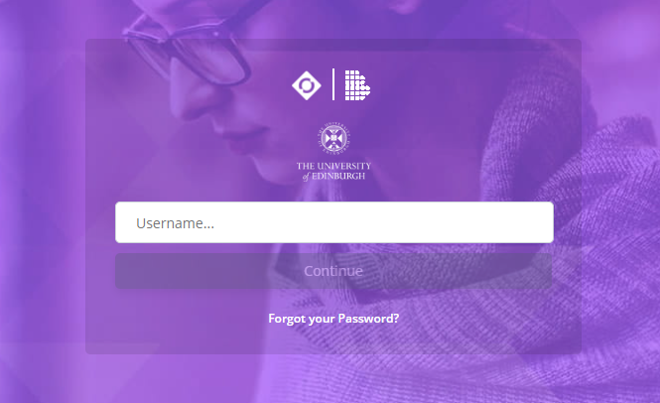

Making a booking
- To make a room booking, firstly, make sure that the ‘Rooms’ icon is selected. 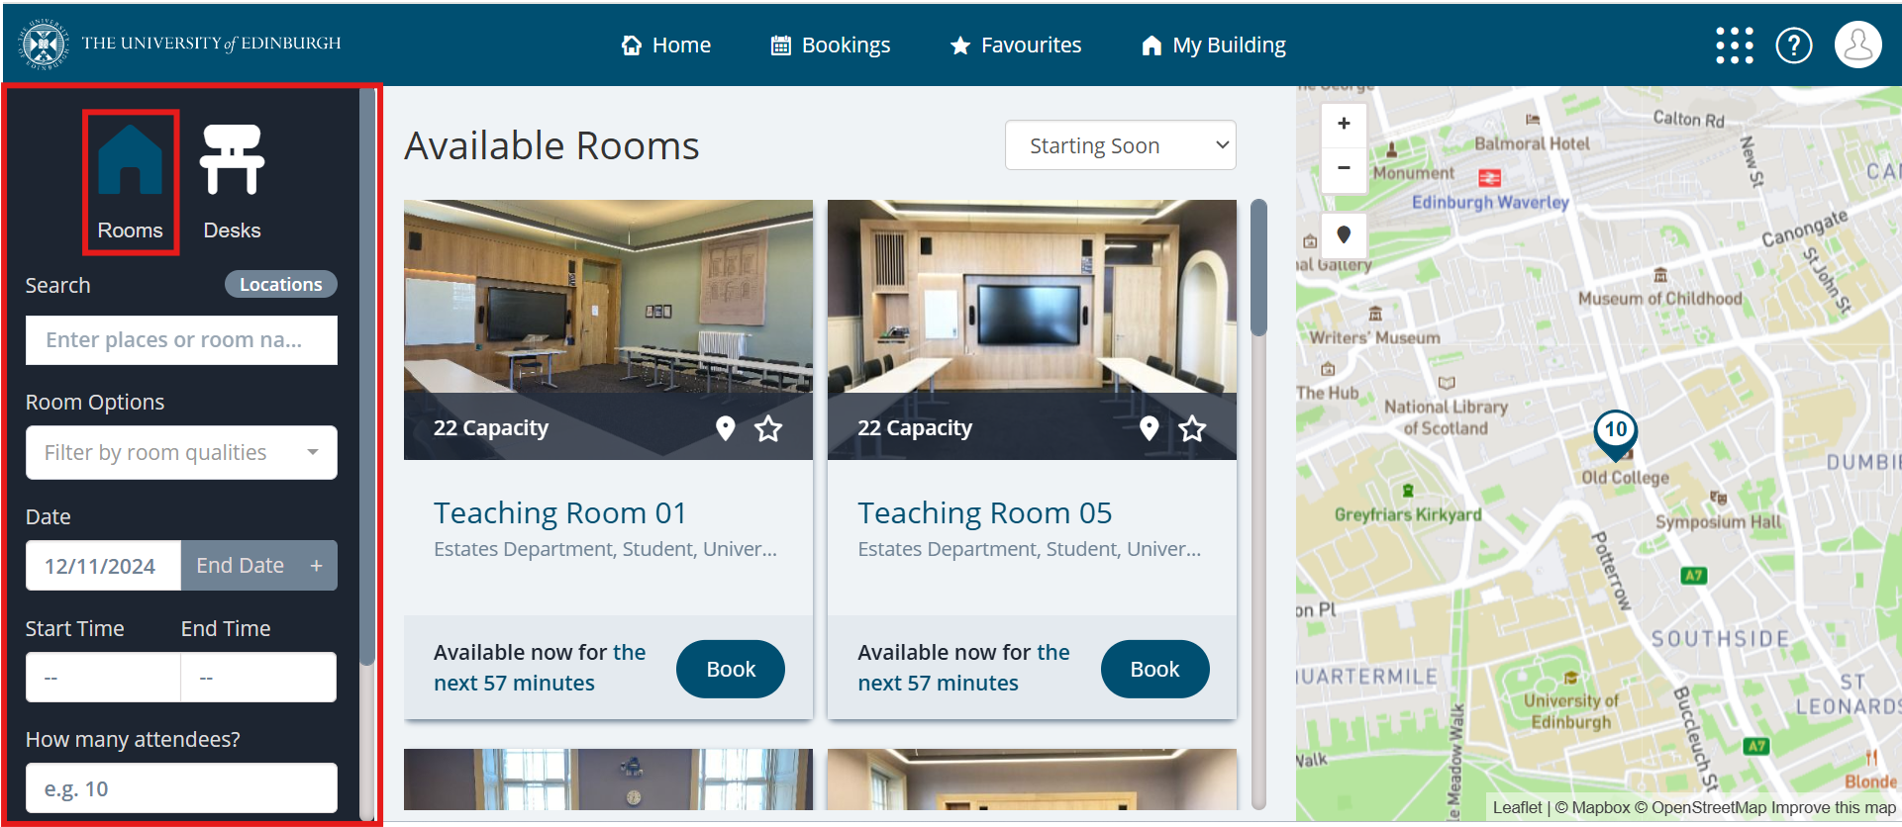

- Then, choose ‘Accessible Study Space’ from the drop-down menu or type ‘Accessible Study Space’ in the Search box.
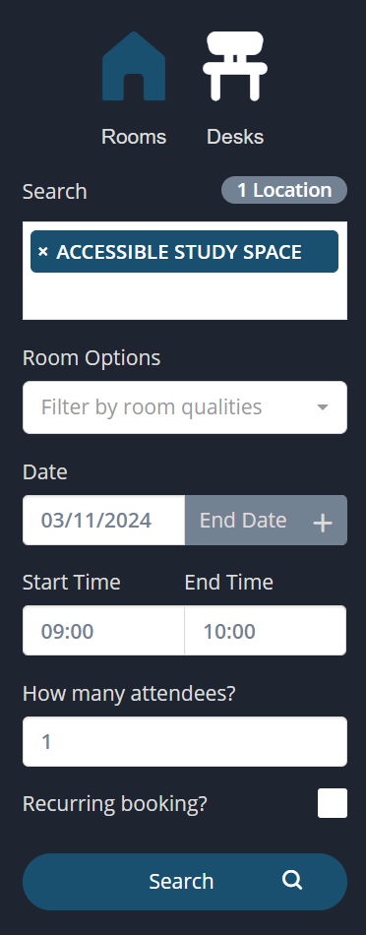

- Choose your dates and times.
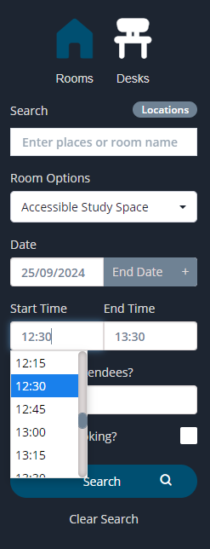

- Click on ‘Search’
- You should see all available options, so choose the room you have a key for and select ‘Book’. You can click on the star icon to add the room to your Favourites.

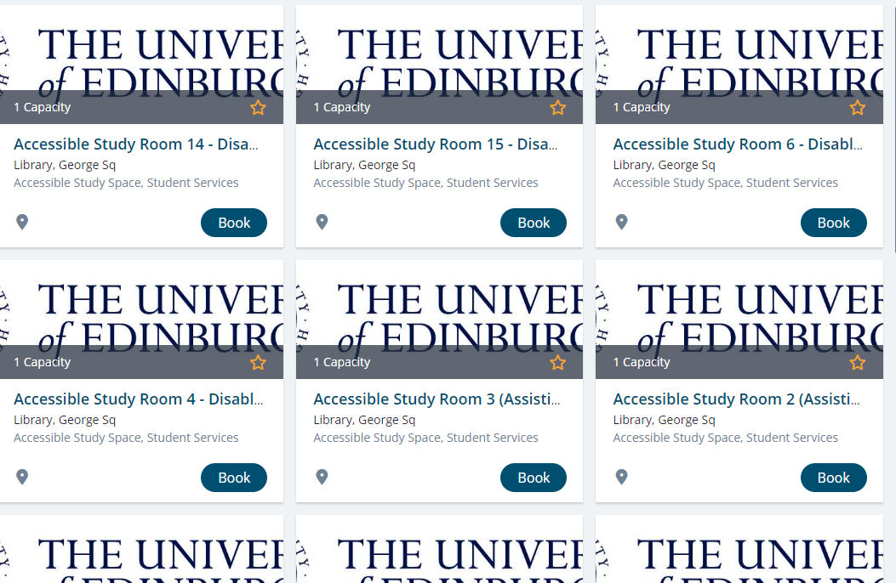

- Fill in the fields marked with a red asterisk * and then click on ‘Make Booking’.
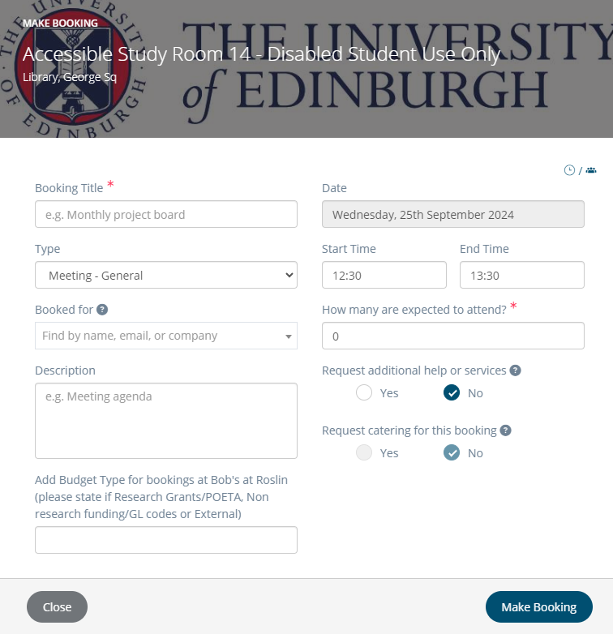

- You should be able to see your bookings by pressing a ‘Bookings’ option at the top of the page and then selecting ‘My Bookings’.

Example of how a booking will appear:
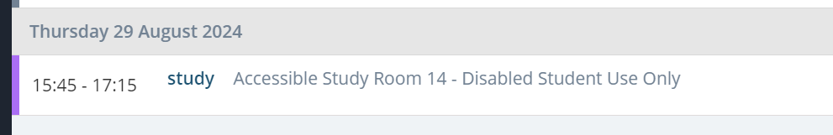

Cancelling or updating bookings
- Bookings can be cancelled or edited by clicking ‘Bookings’ option at the top of the page.
  - Choose ‘Cancel Booking’ to cancel. Importantly, Bookings can’t be cancelled once the booking has started but they can be ended early to free up the room for another student.
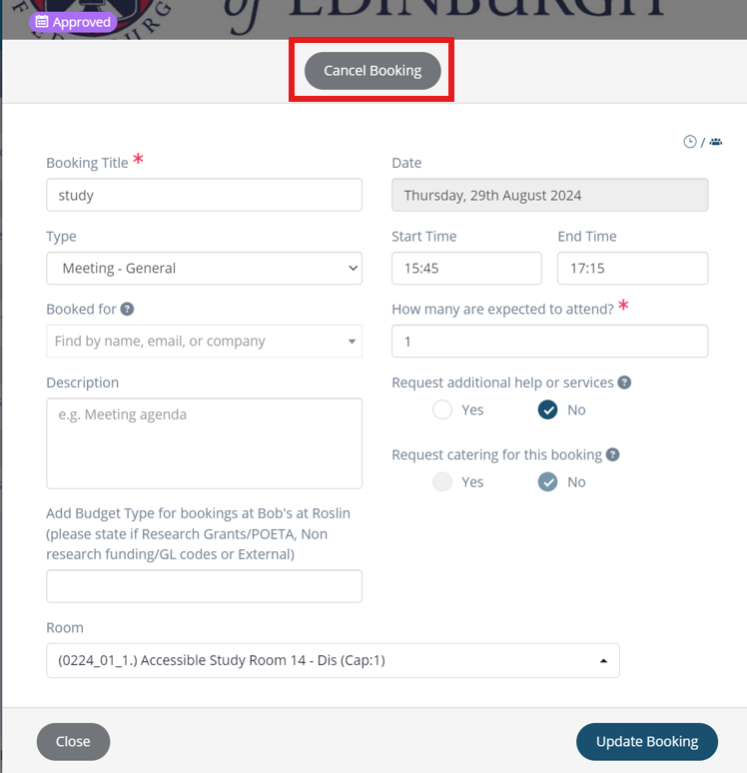
  - To change times or end a booking early, amend the Time fields and choose ‘Update Booking’.
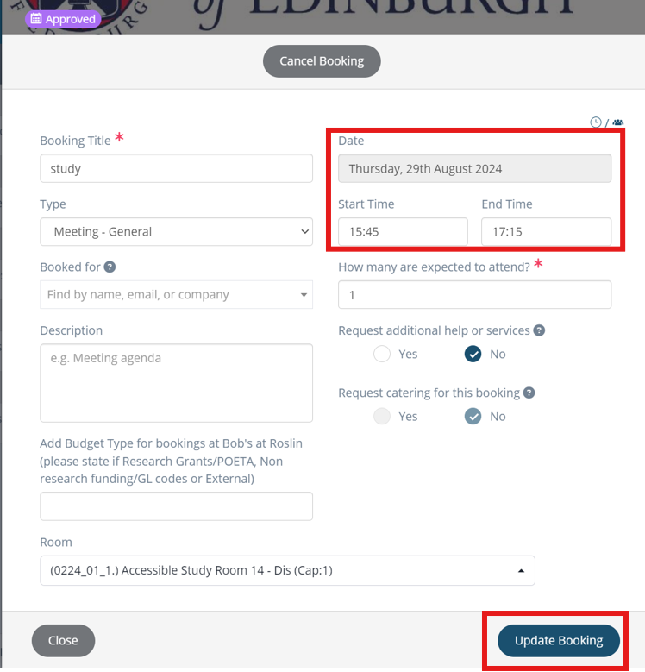

Booking rooms on a mobile phone
The booking system looks slightly different on mobile phones.
- Find the ‘Home’ page and click on ‘Search’.
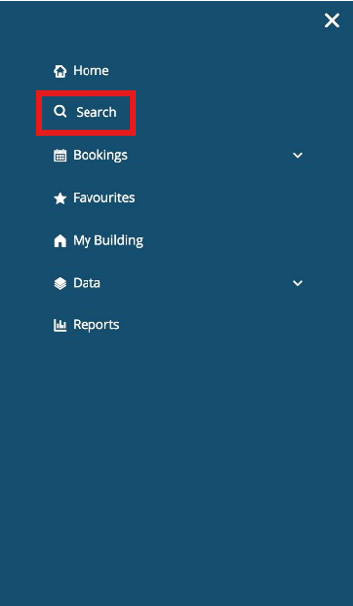
- There is no drop-down menu, so use the ‘Search’ box to find ‘Accessible Study Space’.
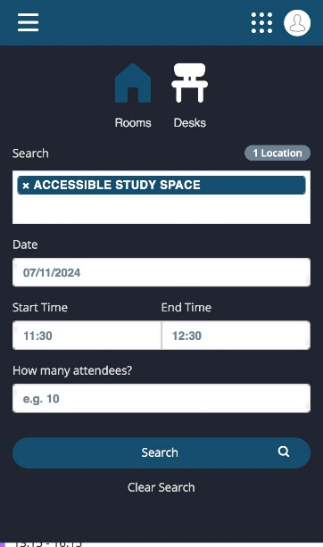
The rest of the booking process is the same as the desktop version.

Useful information
- Rooms can be booked once a day for up to 4 hours.
- Rooms can be booked 14 days in advance.
- Rooms can be added to Favourites (by clicking on the star icon) to make booking easier.
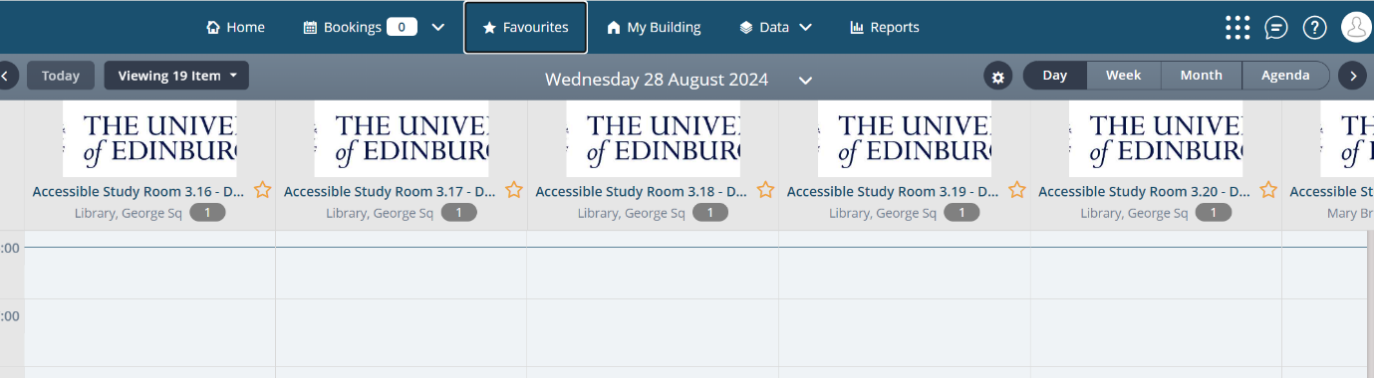

Regulations/Etiquette
- Bookings can be made for a maximum of 4 hours.
- Users can only make one booking a day.
- Rooms are for individual usage and are not available for group work*.
- Eating is not permitted in any of the study rooms.
- If studying with music, headphones must be used.
- Do not use the room to make social mobile calls and keep all other calls, including Teams meetings, to a minimum as this can disrupt other users.
- Lock the door when you leave the room.
- If the room is vacant but booked, you may use the room until the booker shows up for their session.
- Ensure you take all belongings with you when you leave and do not leave personal belongings in the room.
- Leave the space clean and tidy and remove all litter.
*Students may be accompanied by support workers

