Assistive Technology loans for Staff – Laptops & Tablet Devices

To request this document in an alternative format e.g. large print, Braille etcetera please contact Jed Bajai via email at Jed.Bajai@ed.ac.uk
Laptop | Make and Model | Equipment Description | Serial No:
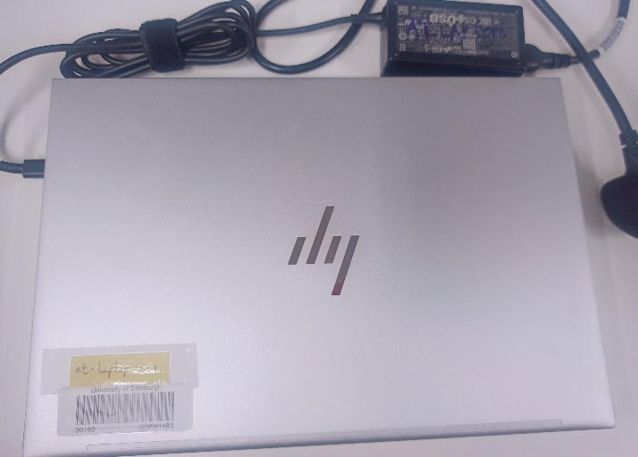 | HP EliteBook 840 G11 Laptop  At-laptop-001.is.ed.ac.uk | Intel Core Ultra 5 135U - 1600MhZ  16gb RAM  512GB SSD  14 inch screen  Dragon Naturally Speaking 16 & ZoomText 25 &  TextHelp Read&Write 12 software installed. | S/N=5cg4451jc8  P/N=8m4w7av
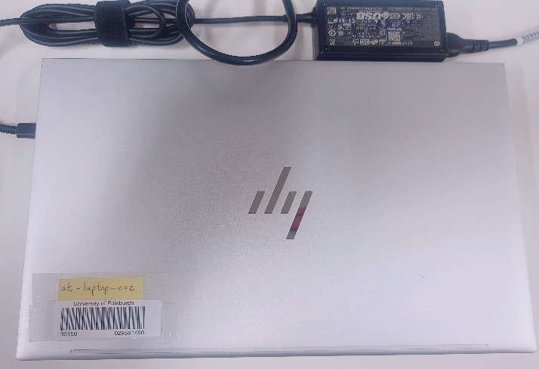 | HP EliteBook 840 G11 Laptop  At-laptop-002.is.ed.ac.uk | Intel Core Ultra 5 135U - 1600MhZ  16gb RAM  512GB SSD  14 inch screen  Dragon Naturally Speaking 16 & ZoomText 25 &  TextHelp Read&Write 12 software installed. | /N=5cg4451jc7  P/N=8m4w7av

Tablet Devices | Make and Model | Equipment Description | Serial No
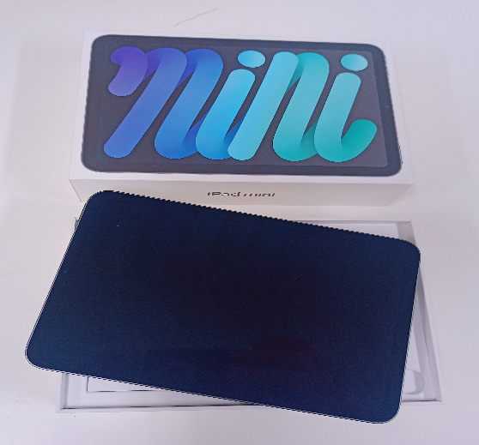 | Apple iPad | Apple iPad Mini - IOS  64Gb - 6th Generation  With USB-C Charger Cable + Power Adapter | K7TV664R60

