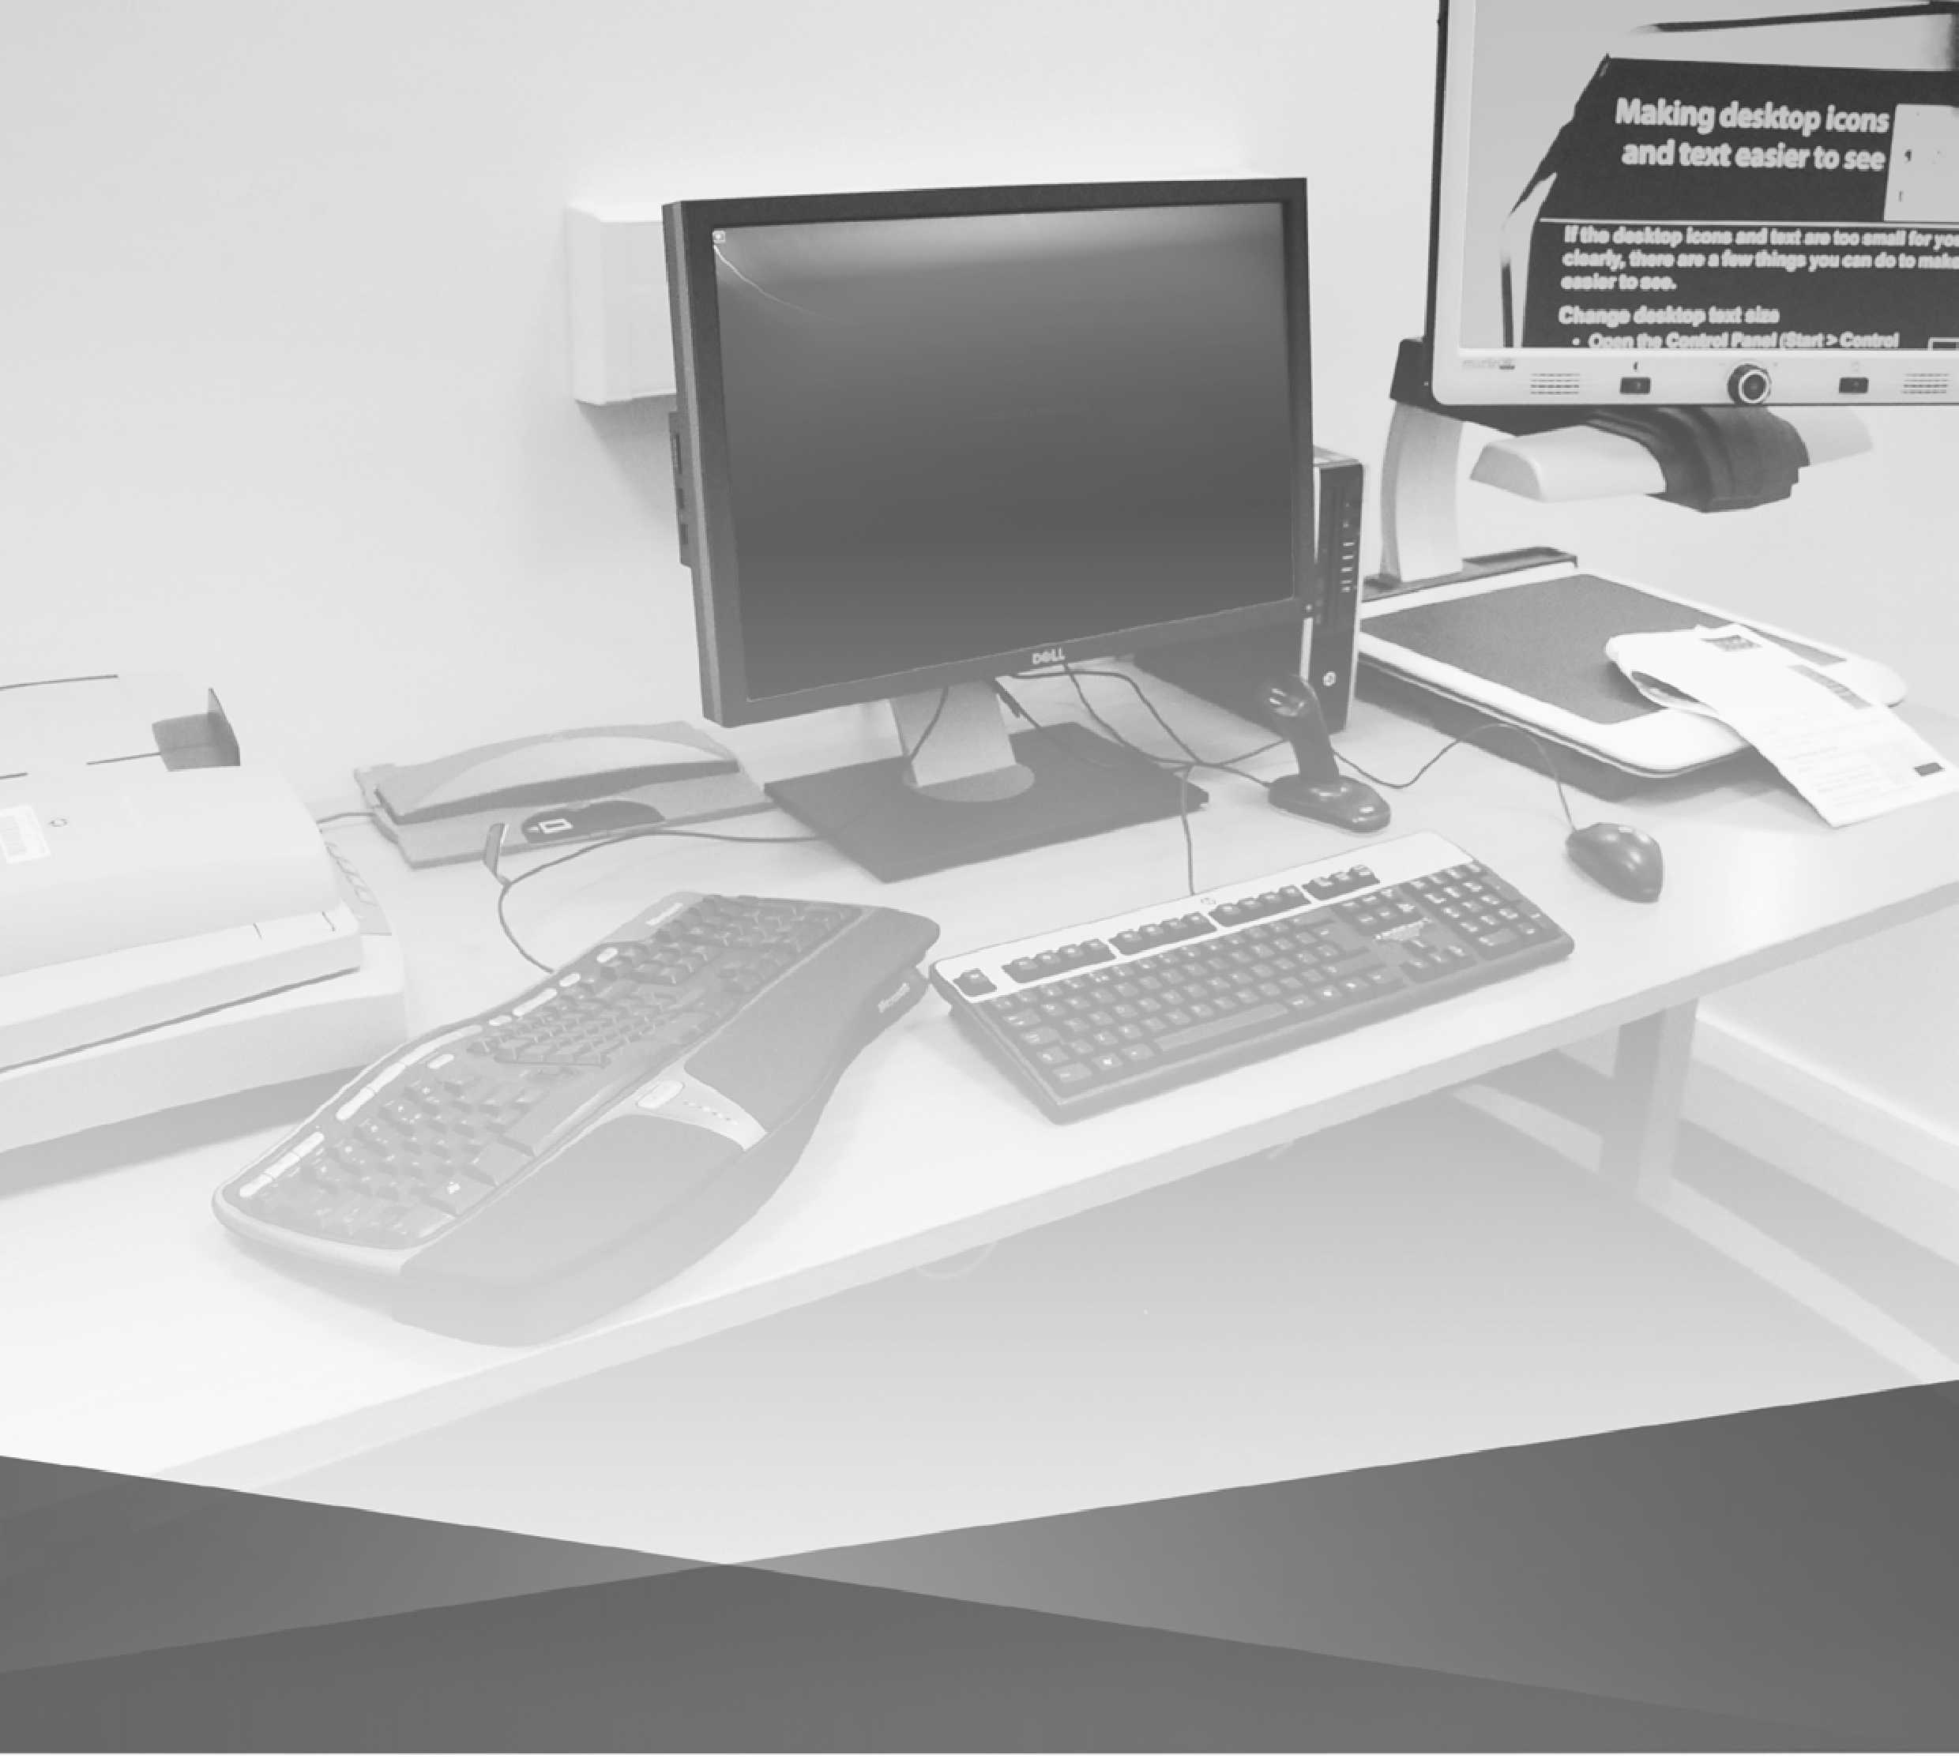

Accessible PC

Quick Start Guide

[www.ed.ac.uk/is/accessibility/pcs](http://www.ed.ac.uk/is/accessibility/pcs)

[IS.Helpline@ed.ac.uk](mailto:IS.Helpline@ed.ac.uk)

For advice and assistance with this computer please contact IS Helpline:

[IS.Helpline@ed.ac.uk](mailto:IS.Helpline@ed.ac.uk)

This document contains a number of screenshots and we appreciate that these may not be accesible to everyone. If you would prefer to have an in person discussion about accessible hardward and software available please contact Jed Bajai by email [Jed.bajai@ed.ac.uk](mailto:Jed.bajai@ed.ac.uk) or phone 0131 504 553

To request this document in an alternative format, email [lori.anderson@ed.ac.uk](mailto:lori.anderson@ed.ac.uk) or call 0131 650 6645

Contents

Introduction 4

Making desktop icons and text easier to see 5

Windows 10 Ease of Access Center 7

Optical Character Recognition scanning with ABBYY

FineReader 8

Scanning with Adobe Photoshop 11

ZoomText Magnifier and Reader 13

Jaws Professional Screen Reader 14

CCTVs, desktop magnifiers and readers 15

Keyboards and mice 17

Accessible PC Locations 18

Accessible PC Locations: Central Area 19

Accessible PC Locations: King's Buildings & Easter Bush 24

Introduction

This computer has been set up as an accessible workstation. It has the same software as standard open access lab computers plus additional assistive software and hardware to make it more accessible to users with disabilities. They have priority.

**The following additional assistive software is installed on this computer:**

* ABBYY FineReader 11 (optical character recognition)
* Adobe Digital Editions (accessible e-Book reader)
* Adobe Creative Cloud (image scanning and editing)
* ZoomText Magnifier and Reader 2022

**AutoCAD computer aided desig**n software and **UniSim process modelling software** is available on both of the Accessible PCs located in the Noreen and Kenneth Murray Library.

**JAWS screen reading software** is available on the PCs in Accessible Study Room 1, Noreen and Kenneth Murray Library and Accessible Study Room 2, Main Library.

**Dragon Naturally Speaking voice recognition software** is available on the PCs in Accessible Study Rooms 1 and 3, Main Library.

**The following assistive software is installed on this Accessible PC and on all Open Access Lab PCs:**

* Adobe Digital Editions (e-book reader) 4.5
* Inspiration 9 (mind mapping)
* MindGenius Business Enterprise (mind mapping) 2019
* Sonocent Audio Notetaker 3.1 (interactive note-taking)
* Texthelp Read And Write 12 (literacy support)

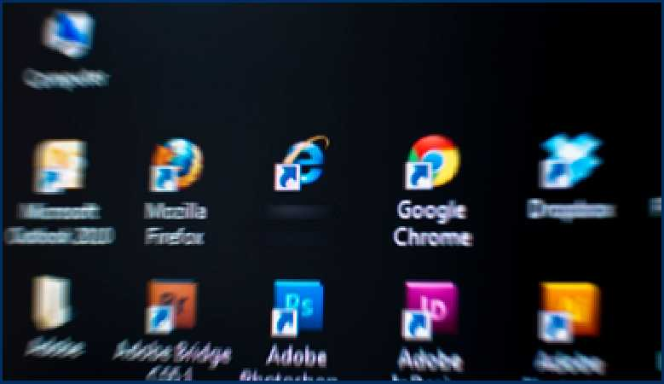**Making desktop icons and text easier to see**

**Internet**

**Explorer**

**If desktop icons and text are too small for you to see clearly, there are a few things you can do to make them easier to see.**

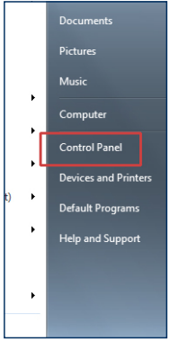**Change desktop text size**

* Right click on Desktop area and choose **Personalize**
* Then select **Themes** and **Desktop Icon Settings**.

**Note:** depending on the Windows 10 set-up, the **Display** option can be available in the **Control Panel** without having to go through the **Appearance and Personalization** panel first.

* Select the **Medium** or **Larger** radio button to change text size (the default text size is **Smaller**).
* Log off and on again to apply changes made in the Display panel.

**Change desktop icon size**

* 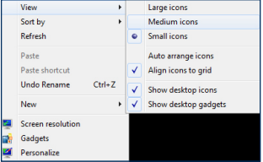Right click on a blank area of the desktop.

,

* From the drop-down menu select **View**, then select **Large icons** or **Medium icons** from the sub­menu.
* The icons will change size

immediately when you select the preferred setting.

**Making desktop icons and text easier to see (continued)**

**Change screen resolution**

You can also make all on-screen objects larger by changing the screen resolution, though this will result in a smaller desktop workspace.

* To change the screen resolution, **right click** on a blank area of the desktop and select **Display Settings** from the menu.
* In the **Display resolution** section, you will see a drop down displaying the current screen resolution, which will probably be indicated as the **recommended** resolution.
* Select the drop down and choose a different resolution if desired.

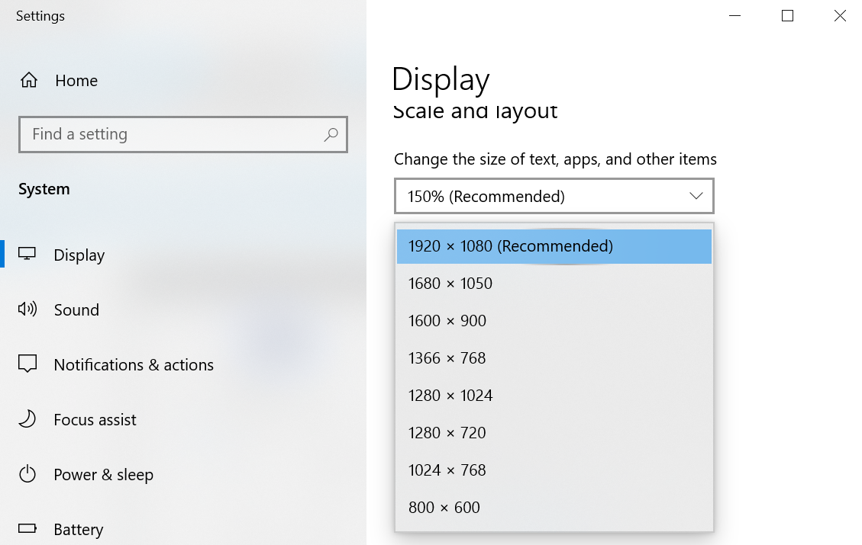

* When you are satisfied with the selected resolution (you may want to experiment with different dimensions), click the **Apply** button. The resolution will change immediately but a small panel will pop up at the same time allowing you fifteen seconds to reject the resolution change if you prefer not to keep it.

**Note:** All the above changes will normally be retained when you log into any University open access PC. You can use the procedures above to reverse or make further changes on any open access PC.

**Windows 10 Ease of Access Center**

**The Windows 10 Ease of Access Center provides information, common tools and links which will allow you to make changes to the computer to suit your accessibility requirements.**

To open the Ease of Access Center, choose:

**Start > Settings > Control Panel > Ease of Access Center**

The narration and window scanning options are set to ‘on’ by default (the check boxes will be ticked) and, assuming the computer’s sound is enabled and you are using headphones, you will hear the scanning narration immediately after the Ease of Access Center is launched.

Both narration and scanning can be switched off by un-ticking the appropriate boxes in the first section of the Ease of Access Center.

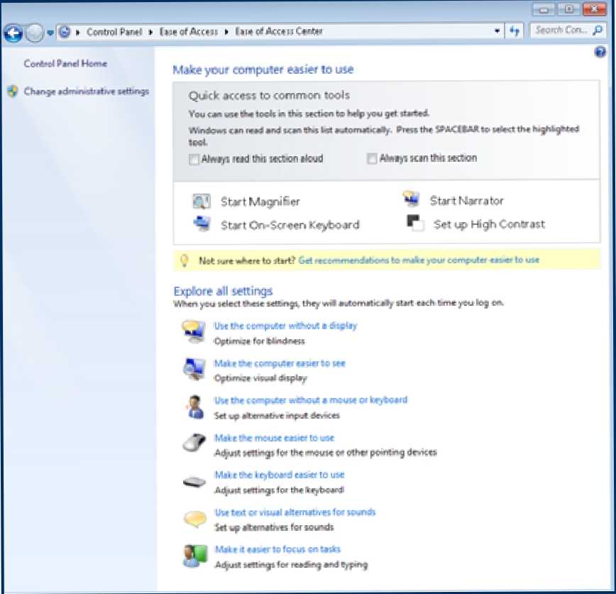In the same section, you will find Quick Access buttons to the most commonly used accessibility tools; Magnifier, Narrator, On­screen Keyboard and High Contrast.

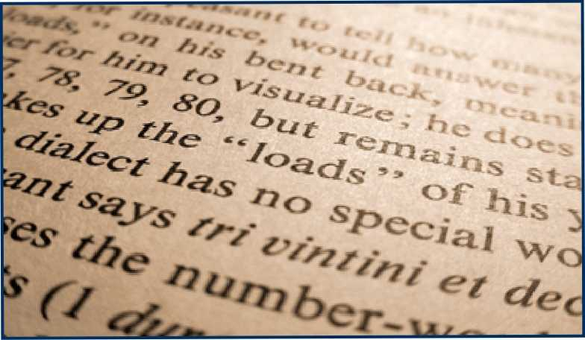**Optical Character Recognition scanning with ABBYY FineReader 11**

**ABBYY FineReader 11 software converts paper and electronic documents into a variety of accessible formats, e.g. from paper to editable text files such Word or RTF (Rich Text Format.**

**The following explains how you can use the program to scan a paper document, correct it using FineReader’s in-built OCR (Optical Character Recognition) and proofreading tools, and then save it as a Word file.**

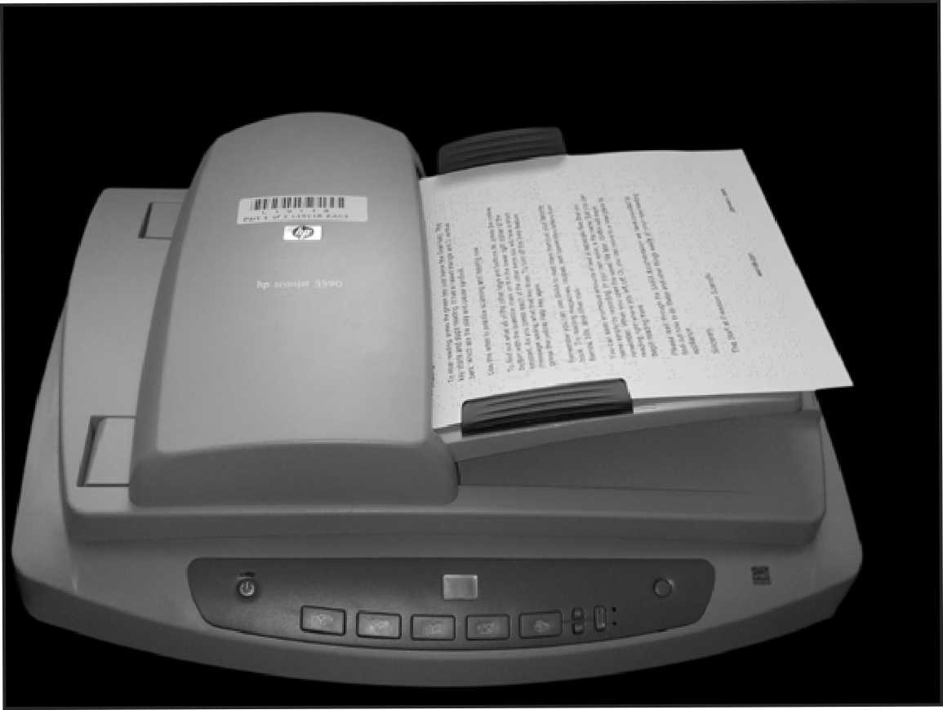Make sure the scanner is switched on and connected to the PC.

Place the document or image you wish to scan in the scanner.

When scanning multiple documents with a scanner which has a document feeder (see image right), place the documents face up in the feeder.

When scanning images, place them face down on the scanner’s glass surface.

**Note:** You can use ABBYY with a scanner which has no document feeder but multiple document scanning will take longer. If you prefera scanner with a document feeder, see the Accessible PC location information at the end of this guide. Please be aware that some of these scanners are located in Accessible Study Rooms and only available to key-holders.

Select **Start > All Programs > ABBYY FineReader 11 > ABBYY FineReader 11.**

If the FineReader license agreement appears when the programme starts, click **Accept** to close it and continue.

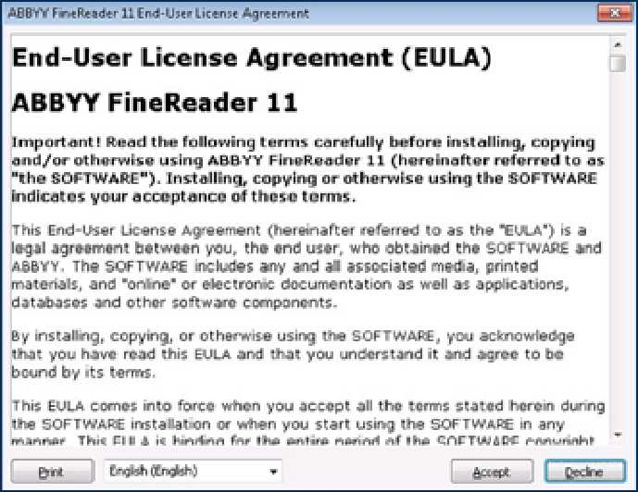

The ABBYY Welcome screen window will now open.

Select your preferred scanning task, e.g. Scan to Microsoft Word.

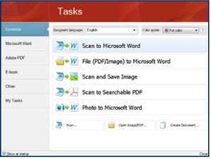

Click **OK** to confirm the scanner model.

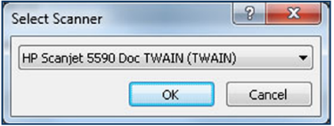

You can now adjust the scanning options. For multi-page document scanning, expand the **Multi-Page Scanning** option and tick both boxes, if appropriate

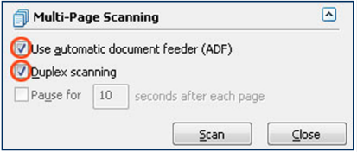

ress the **Scan** button to begin scanning. When scanning is complete, click on the **Close** button.

ABBYY will now attempt to recognize the contents of your document before opening it in Microsoft Word.

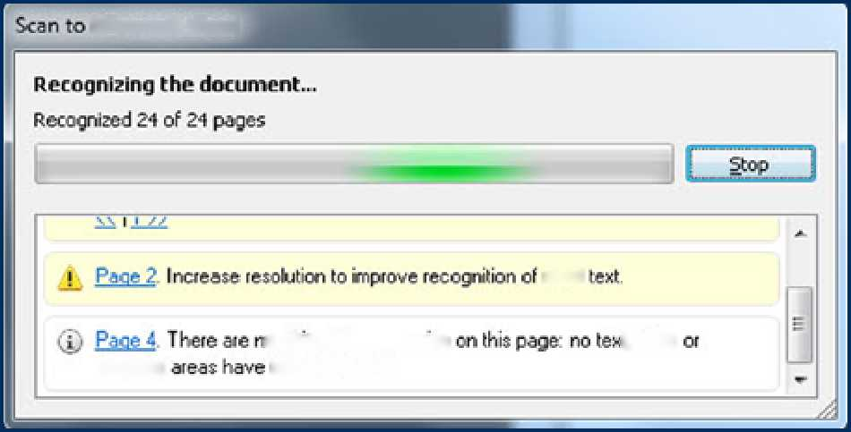

**Microsoft Word**

**small**

**i table**

**barcode**

**о objects to recognize been delected**

When the Word document opens, you have the option to resolve errors which ABBYY has picked up during the character recognition stage.

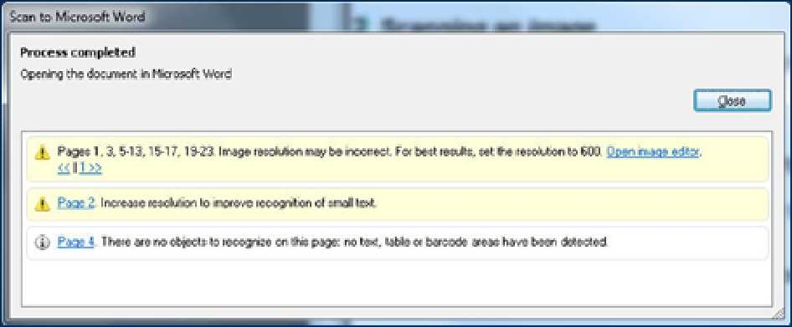

When errors have been resolved, press the **Read** button on the ABBYY toolbar at the top of the screen to re-recognize the text before sending it to Word.

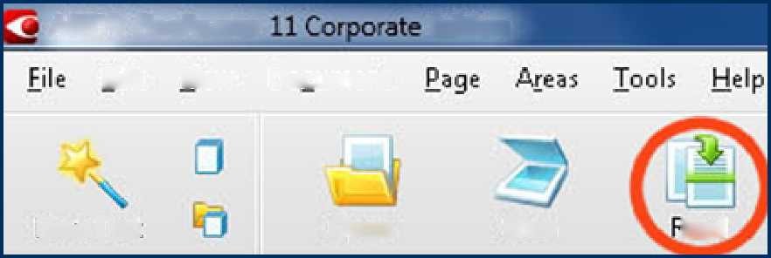

**ABBYY FineReader**

**Edition**

**Edit**

**New Task**

**Open**

**Scan**

**lead**

**View Document**

A new Word document will open containing your scanned text or image with any edits you have carried out.



**Scanning with Adobe  
Photoshop**

**Photoshop can be used to scan images and has many editing features.**

You can use Photoshop to create a scanned image, then edit and save it as a JPEG or other image file format.

Make sure the scanner is switched on and connected to the PC.

Place the document you want to scan face down on the scanner’s glass surface.

Select **Start > All Programs > Adobe Photoshop**

From the top menu in Photoshop, select **File > Import > WIA Support**. The WIA Support Wizard will open.

:

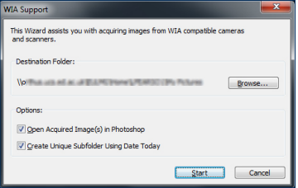

Click **Start** to open the Select Device panel. The scanner should be highlighted in the panel (there will usually only be one choice of scanner).

**Scanning with Adobe Photoshop CS6 (continued)**

Click **OK** to open the Scanning options window.

Make sure the paper source drop-down menu is set to **Flatbed** and then adjust the remaining options as required.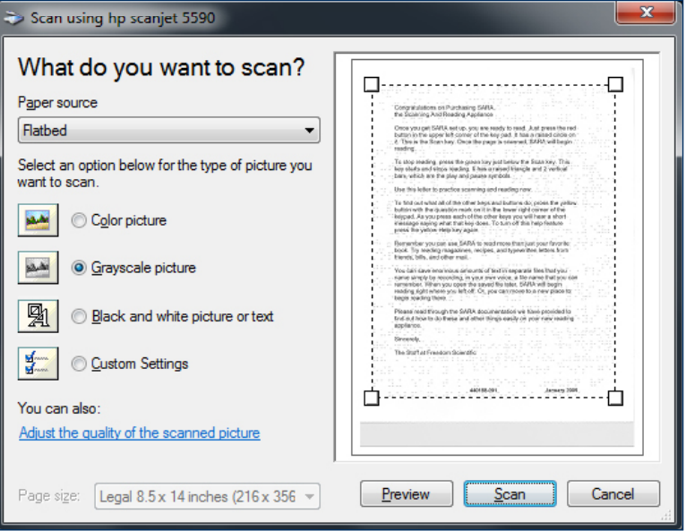

The image can be previewed prior to scanning. Previewing will allow you to adjust the area to be scanned by dragging the **marquee** edges (the dotted line seen in the above image) to the preferred position for capturing the required image area.

When you are satisfied with the settings, click the **Scan** button to complete the task.

The scanned image will open within Photoshop where it can be colour or size edited then saved to the file format of your choice, including jpg, pdf, tiff, and many more.

**ZoomText Magnifier and Reader**

ZoomText Magnifier and Reader is installed on all Accessible PCs.

It allows the on-screen image to be magnified without loss of quality.

In combination with the use of personal headphones, ZoomText utilises text-to-speech (TTS) technology to read back text entered using the keyboard or from existing documents, web pages and emails.

A choice of reading voices is available and the reading speed can be adjusted.

Other accessibility features include colour contrast and pointer (cursor) adjustments.

The programme can be accessed by double clicking the yellow ZoomText icon on the desktop or from the Start menu:

**Start > All Programs > ZoomText**.

**Jaws Professional Screen Reader 2022**

JAWS Professional 2022 screen reading software has been developed for blind and visually impaired computer users.

It helps users access applications for browsing the Web, reading or writing e-mail messages, working with spreadsheets, or accessing databases.

A manufacturer’s quick start guide and user manual are kept with this documentation where JAWS is available (Accessible Study Room 1, Noreen and Kenneth Murray Library and Accessible Study Room 2, Main Library).

**-**

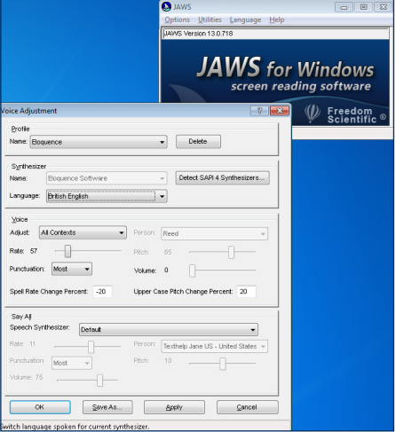

Select **Start > All Programs > JAWS**.

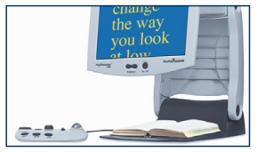**CCTVs, desktop magnifiers and readers**

**MyReader 2**

The MyReader CCTV can digitally capture and store several paper pages for manipulation, as required.

It’s a stand-alone unit with integrated monitor and a separate control pad for adjusting screen colours, reading mode and magnification.

See the large print pamphlet next to each MyReader 2 unit for detailed instructions.

**Merlin elite - HD/OCR Video Magnifier**

The Merlin Elite is an HD desktop magnifier with text-to-speech and optical character recognition (OCR) features. It has a 24 inch widescreen and the large document platform beneath can be used to make notes that can be viewed on the magnifier while being written. Instruction manual available next to the Merlin.

**Humanware Prodigi**

The Prodigi is a high quality magnifyer and text-to-speech reader with OCR features, A4 document platform and touch and tap controls. Instruction manual next to the Prodigi.

**Standard CCTVs**

The standard CCTVs work with the computer’s monitor. When the CCTV is switched on, pressing the Video (or equivalent) button on the monitor should switch between computer and CCTV video outputs.

The wired CCTV control panel provides joystick, button or rotor control of magnification, colour contrast and guide-lines to make reading easier.

**Where are the CCTVs, magnifier and reader units?**

**Merlin Elite magnifier and reader**

* Accessible Study Room 1, first floor, Noreen & Kenneth Murray Library, King’s Buildings

**Humanware Prodigi magnifier and reader**

* Accessible Study Room 3, first floor, Main Library, George Square

**Standard CCTVs**

* Moray House Library, Dalhousie Land, St John Street

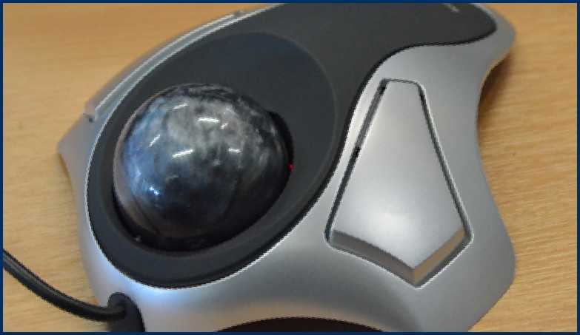

**Keyboards and mice**

**Most of the Accessible PC workstations have specialised keyboards or mice connected.**

The location information at the end of this document provides more information about the types of specialised keyboard or mouse connected to particular Accessible PCs.

Keyboards available with some of the Accessible PCs include:

Ergonomic

BigKeys

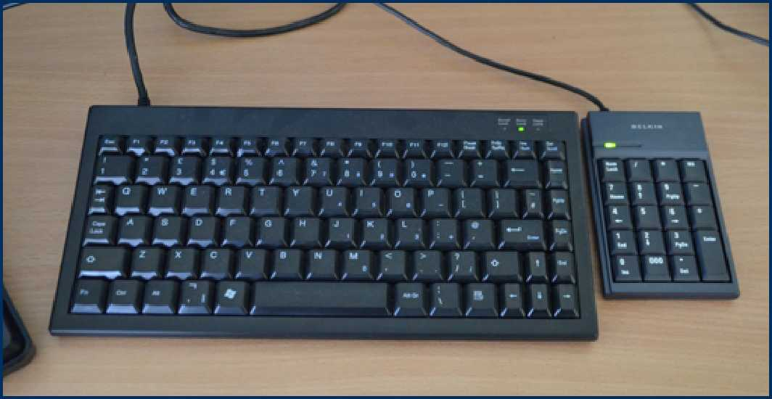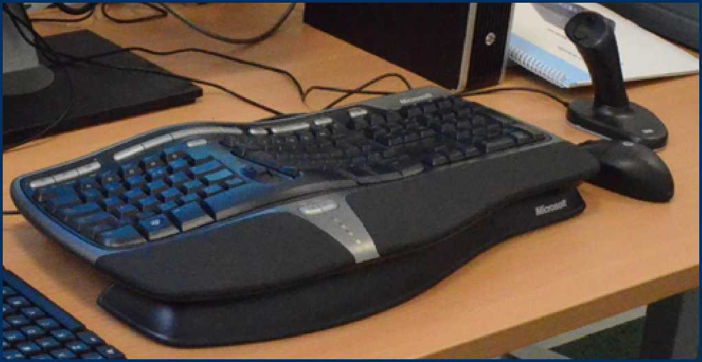Mini

Specialised mice include:

Joystick

Quill

Rollerball

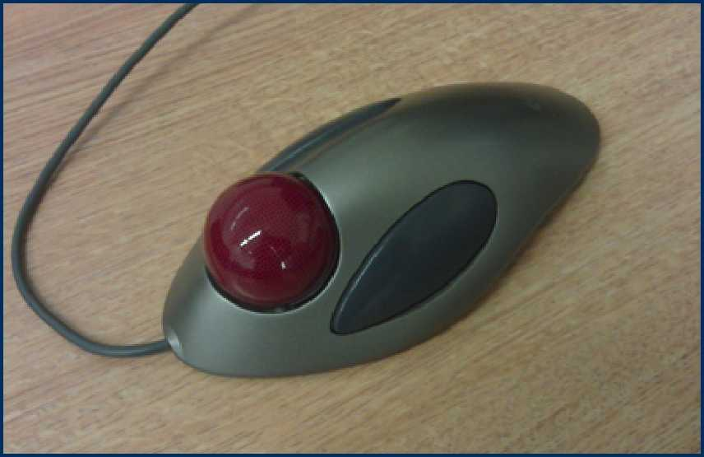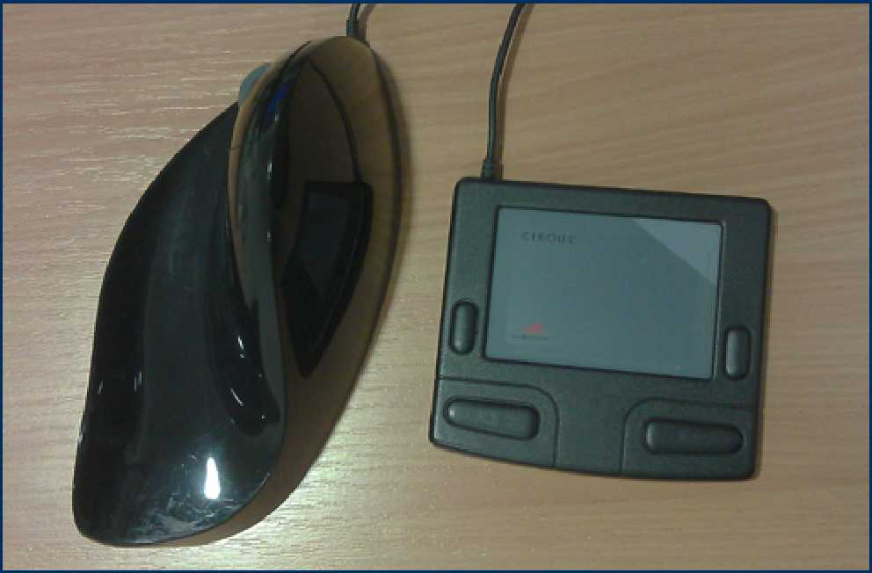

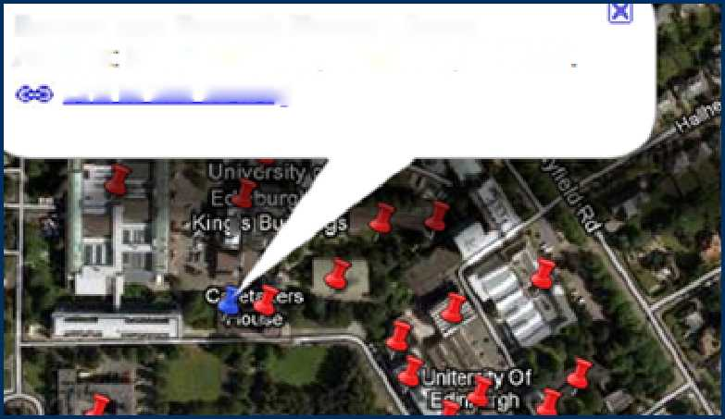This section provides information to help you find Accessible PCs around the University campuses and details the hardware available at each workstation.

**Accessible PC Locations**

**Noreen and Kenneth Murray Library**

Address King's Buildings. Edinburgh. ЕНЭ 3JF Link to this building

**I**

Campus Maps



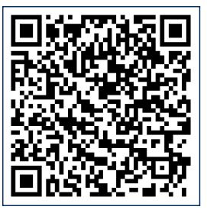

<http://www.ed.ac.uk/maps>

Accessible PCs and Accessible Study [www.ed.ac.uk/is/accessibility/pcs](http://www.ed.ac.uk/is/accessibility/pcs)

Rooms

**Accessible PC Locations: Central Area**

**Main Library, first floor - Accessible Study Room 1**

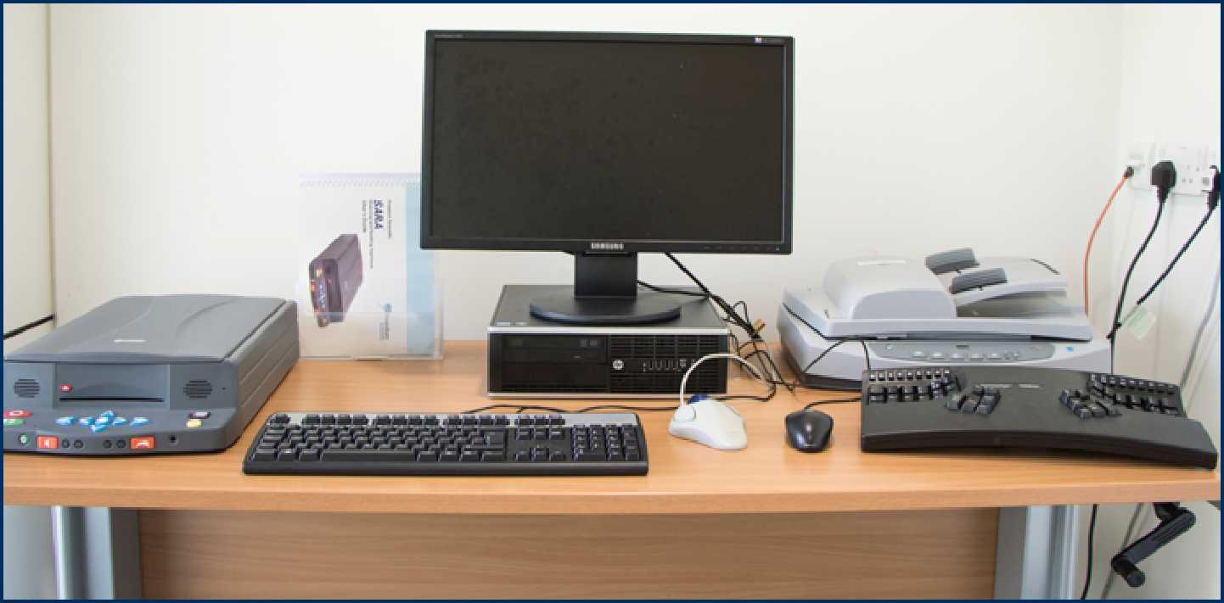**Hardware**

• Kineses Advantage Ergonomic keyboard

* Manual adjustable height desk
* 24 inch monitor
* HP ScanJet 5590 scanner with document feeder
* Kensington Orbital trackball mouse
* SARA scanner / reader

**Additional software:** Dragon Naturally Speaking voice recognition software, JAWS 2022

**Main Library, first floor - Accessible Study Room 2**

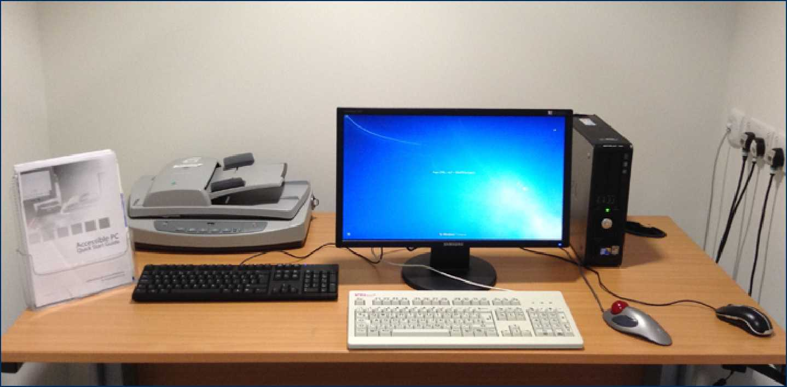**Hardware**

* Manual adjustable height desk
* 21 inch monitor
* HP ScanJet 5590 scanner with document feeder
* Logitech Marble trackball mouse
* BigKeys keyboard

**Additional software:** JAWS screen reading software 2022

**Main Library, first floor - Accessible Study Room 3**

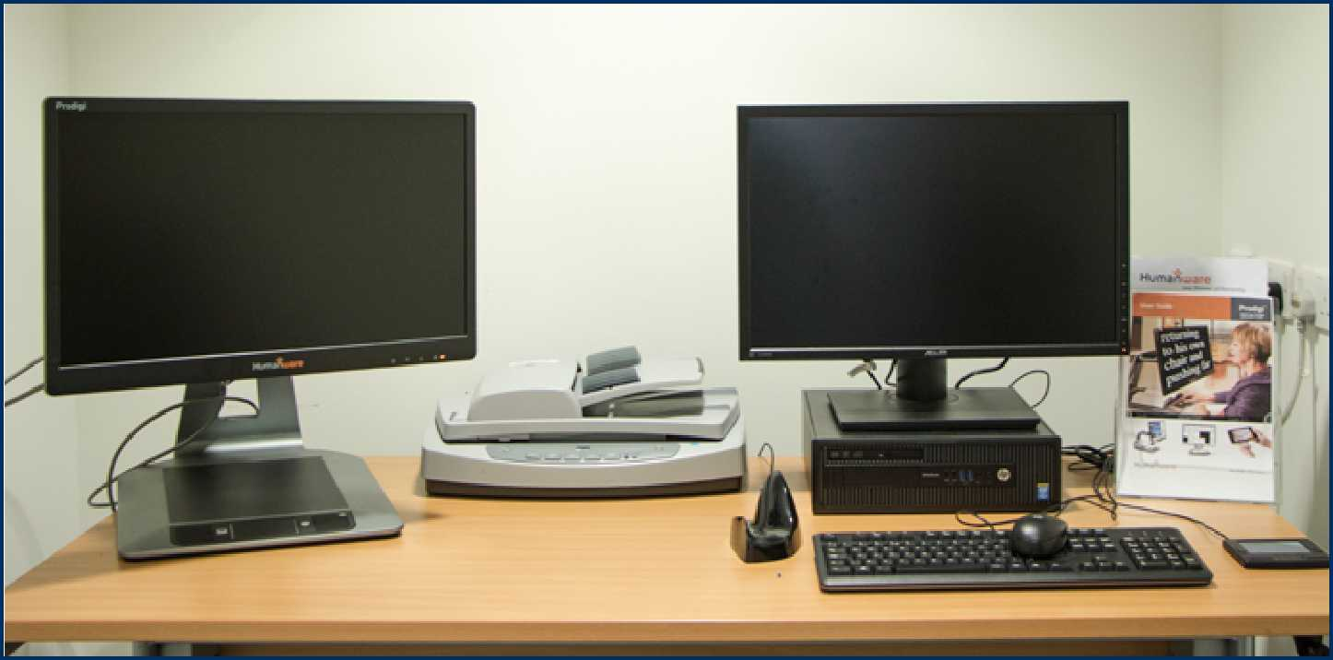**Hardware**

* Manual adjustable height desk
* 21 inch monitor
* HP ScanJet 5590 scanner with document feeder

Humanware Prodigi magnifier and OCR (Optical Character Recognition) reader

* Quill left-hand mouse
* Cirque mouse pad

**Additional software:** Dragon Naturally Speaking voice recognition software

**Hugh Robson Building, George Square, basement lab**

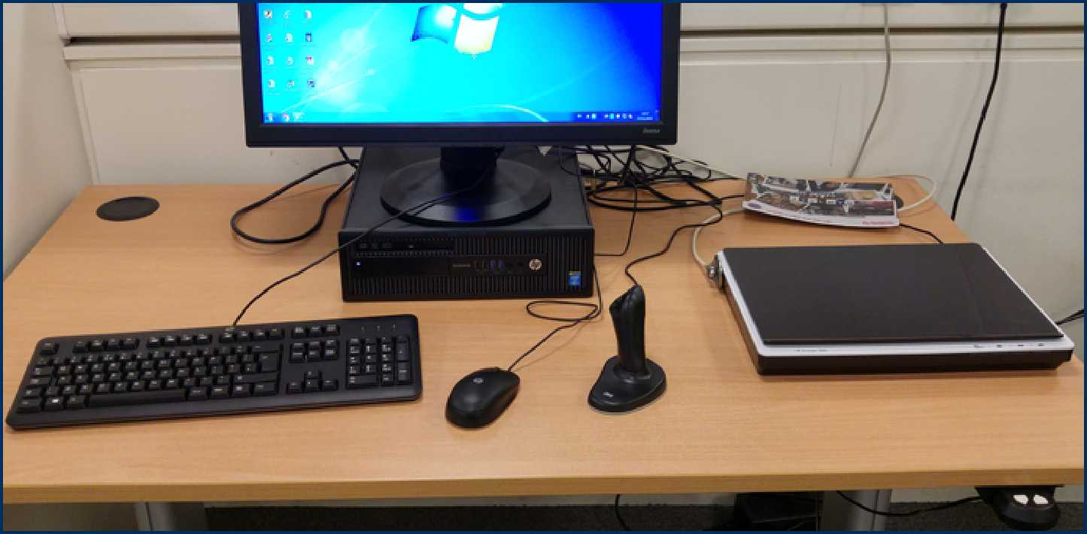**Hardware**

* Motorised adjustable height desk
* 24 inch monitor
* HP ScanJet 200p flatbed scanner
* 3M vertical optical joystick mouse

**Moray House Library, Dalhousie Land, St John Street**

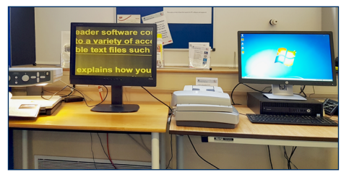**Hardware**

* Manual adjustable height desk
* 24 inch monitor
* HP ScanJet 5590 scanner with document feeder
* Goldtouch Split adjustable keyboard
* Goldtouch number-pad
* AirO2bic quill right-handed mouse
* Tieman CCTV reader

**Holland House Micro-Lab, Pollock Halls**

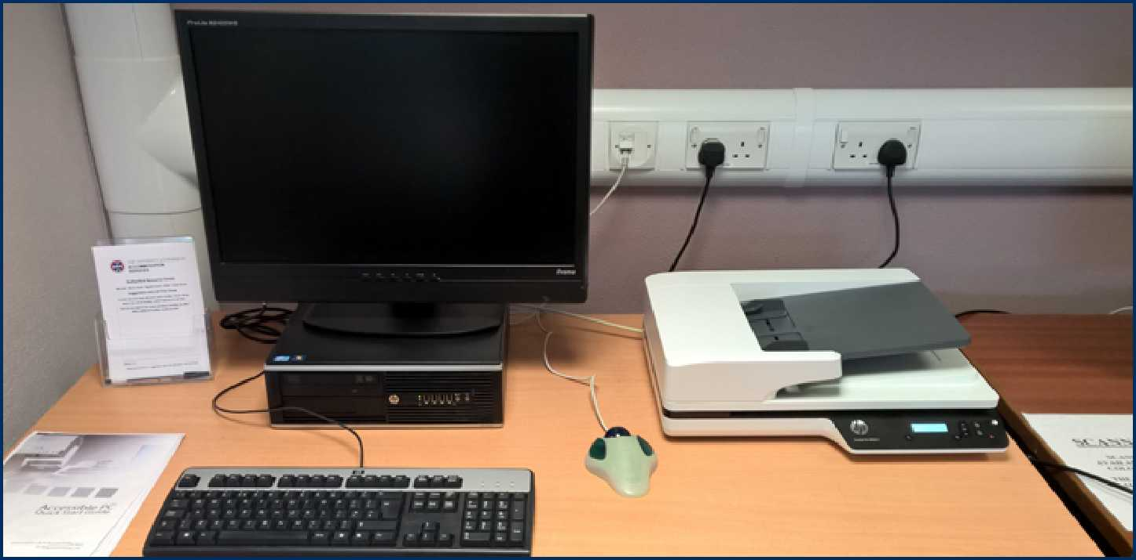**Hardware**

* Motorised adjustable height desk
* 24 inch monitor
* HP ScanJet Scanjet Pro 3500 scanner with document feeder

Kensington Orbital mouse

**Edinburgh College of Art Library, Evolution House**

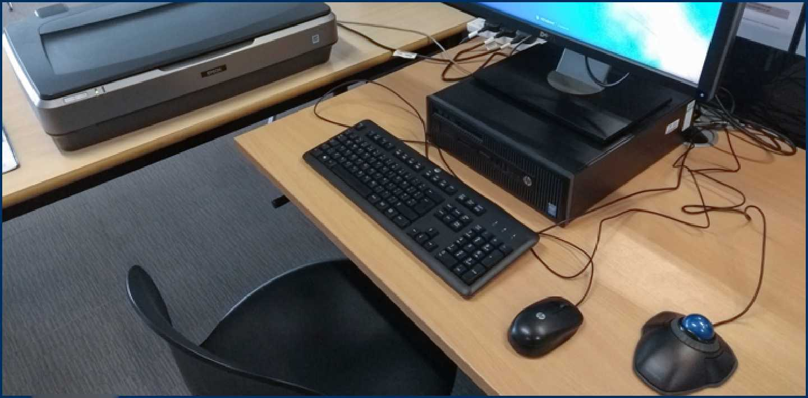**Hardware**

* Manual adjustable height desk
* 24 inch monitor
* Epson Expression 10000 A3 flatbed scanner
* Kensington Orbit trackball mouse

**Accessible PC Locations: King’s Buildings & Easter Bush**

**Noreen and Kenneth Murray Library, first floor, Accessible Study Room 1**

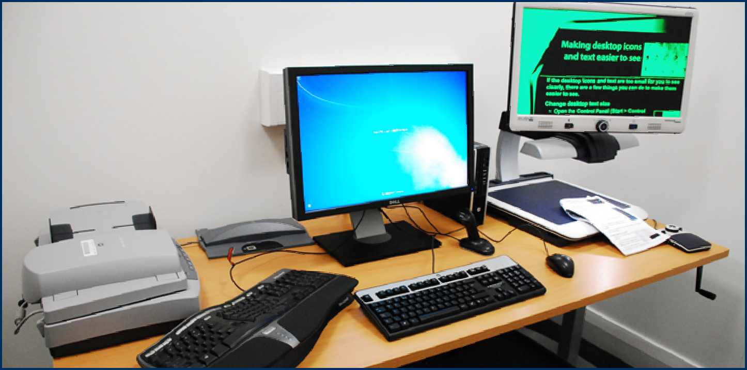**Hardware**

* Manual adjustable height desk
* 24 inch monitor
* HP ScanJet 5590 with document feeder
* Merlin elite HD / OCR / Text to speech CCTV reader
* Microsoft Natural keyboard
* 3M Ergonomic right-handed vertical optical joystick mouse

**Additional software:** JAWS screen reader 2022, AutoCAD and UniSim

**Noreen and Kenneth Murray Library, first floor, Accessible Study Room 2**

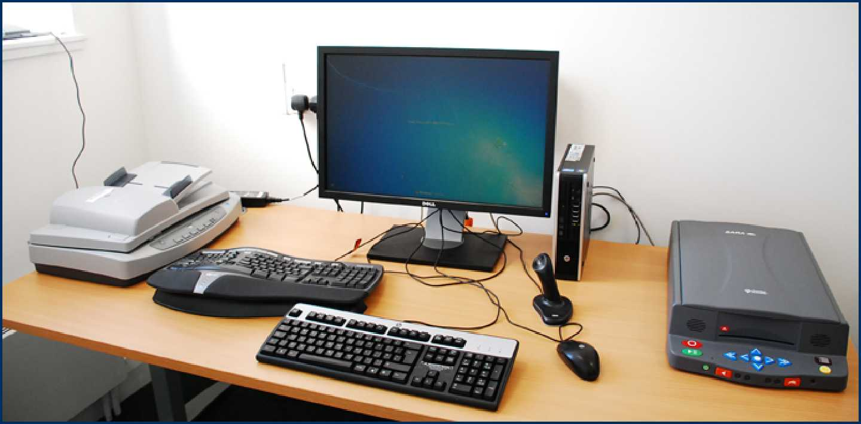**Hardware**

* Manual adjustable height desk
* 24 inch monitor
* HP ScanJet 5590 with document feeder
* SARA scanner / reader
* Microsoft Natural keyboard
* 3M Ergonomic right-handed vertical optical joystick mouse

**Additional software:** AutoCAD and UniSim

**The Lady Smith of Kelvin Veterinary Library, Easter Bush**

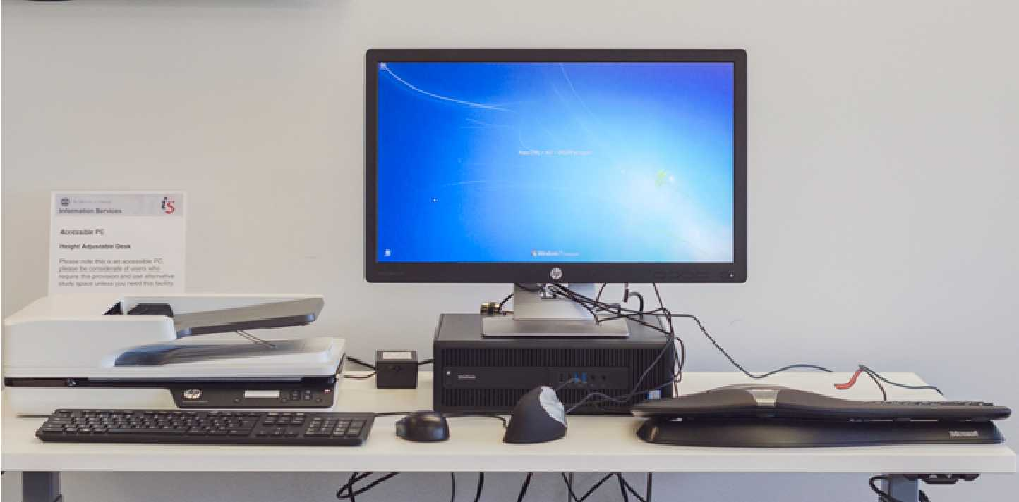**Hardware**

**o**

* Electric adjustable height desk
* 24 inch monitor
* HP ScanJet Pro 3500 scanner with document feeder
* Microsoft Natural keyboard
* Vertical mouse