# Booking Accessible Study Rooms

**To request this document in an alternative format, please contact Viki Galt by email [viki.galt@ed.ac.uk](mailto:viki.galt@ed.ac.uk)**

## Overview

This document shows how to book an accessible study room on a desktop and mobile device, how to cancel or update a booking, and adds other useful information.

## Booking an Accessible Study Room on a computer

### Finding a link to the room booking system

1. Log in to [MyEd](https://www.myed.ed.ac.uk/)
2. Select ‘Studies’ tab on the top-left corner of the page
3. Select ‘Book a study space’
4. Select ‘[Booker – accessible rooms’](https://booker.is.ed.ac.uk/) (a link will open in a new tab)

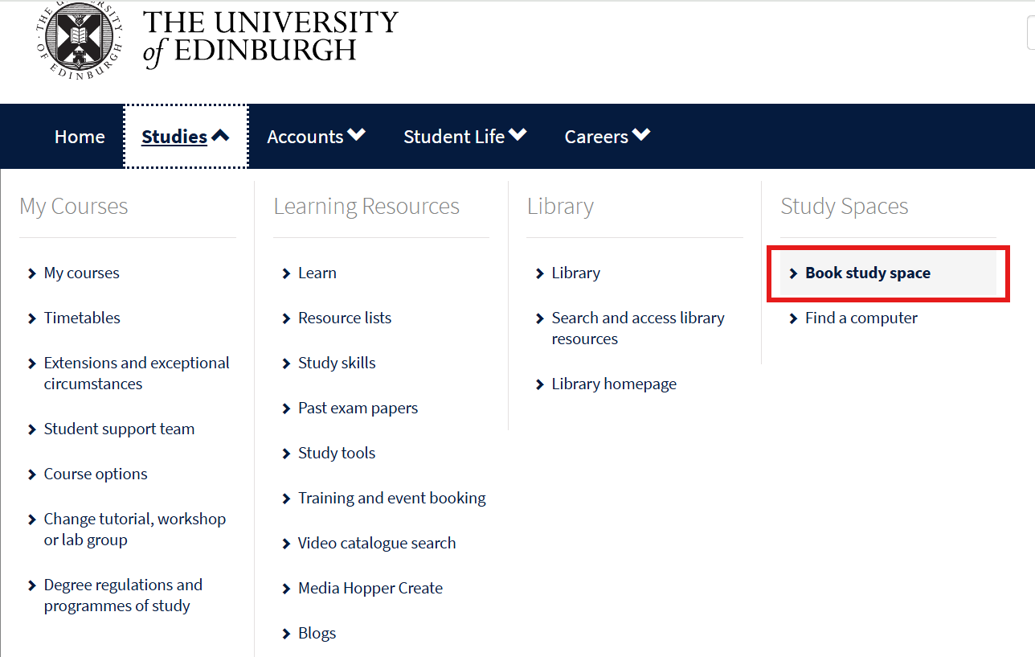

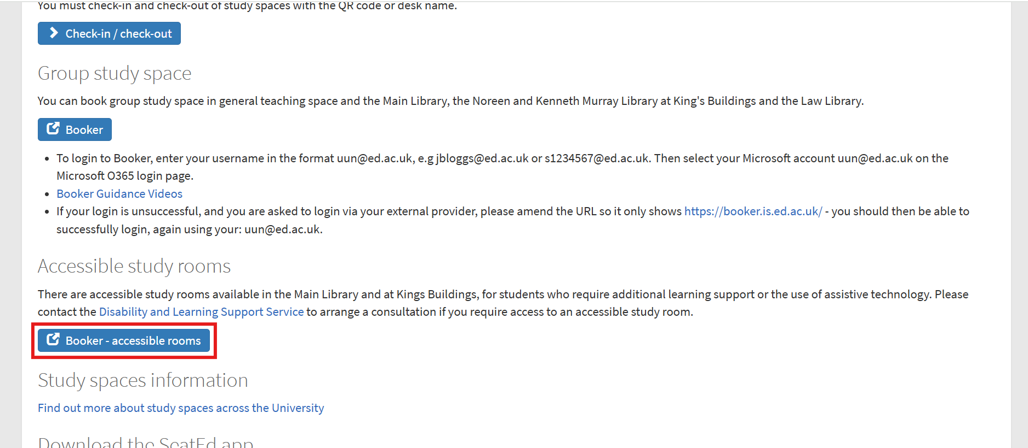

### Logging in

Once the Booker system opens, enter the username (your University email, such as s0000000@ed.ac.uk) and password (your usual University login password) to log in into the system

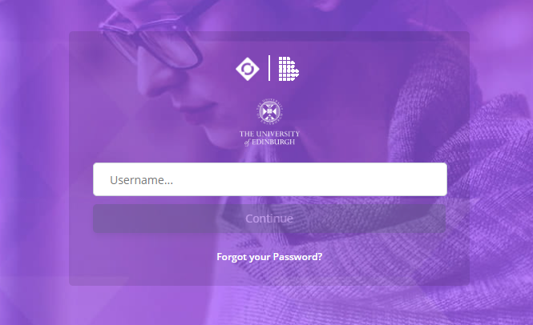

### Making a booking

1. To make a room booking, firstly, make sure that the ‘**Rooms**’ icon is selected. 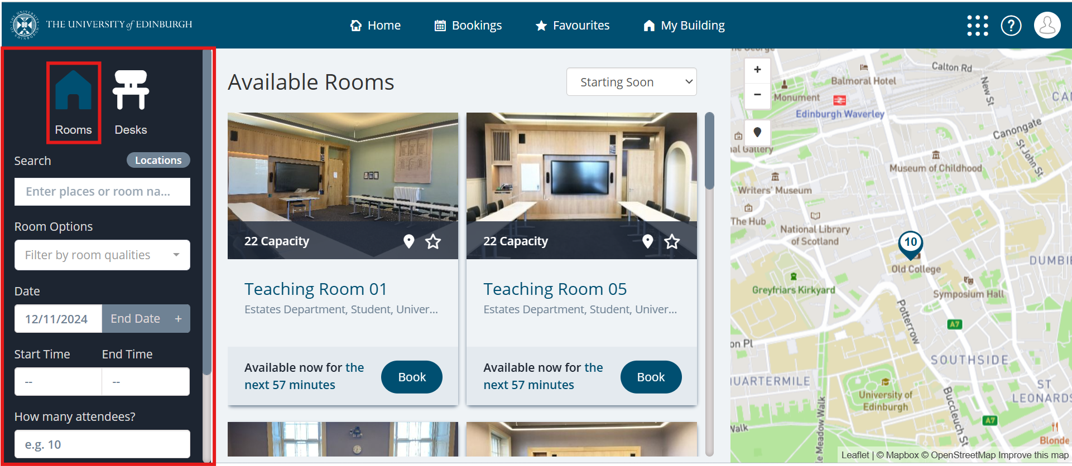
2. Then, choose ‘**Accessible Study Space**’ from the drop-down menu or type ‘Accessible Study Space’ in the Search box.

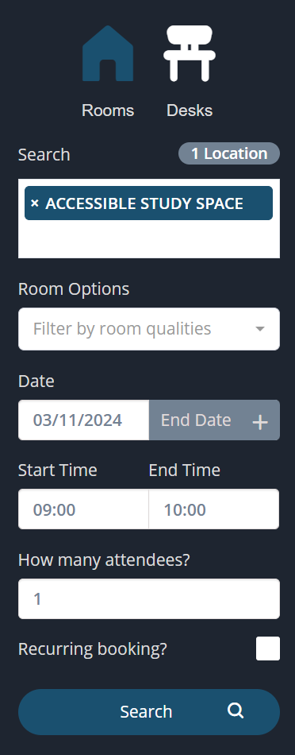

1. Choose your dates and times.

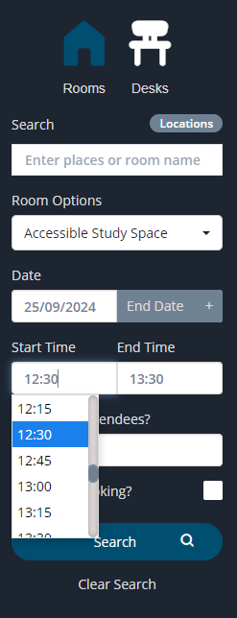

1. Click on ‘**Search’**
2. You should see all available options, so choose the room you have a key for and select ‘**Book**’. You can click on the star icon to add the room to your **Favourites**.

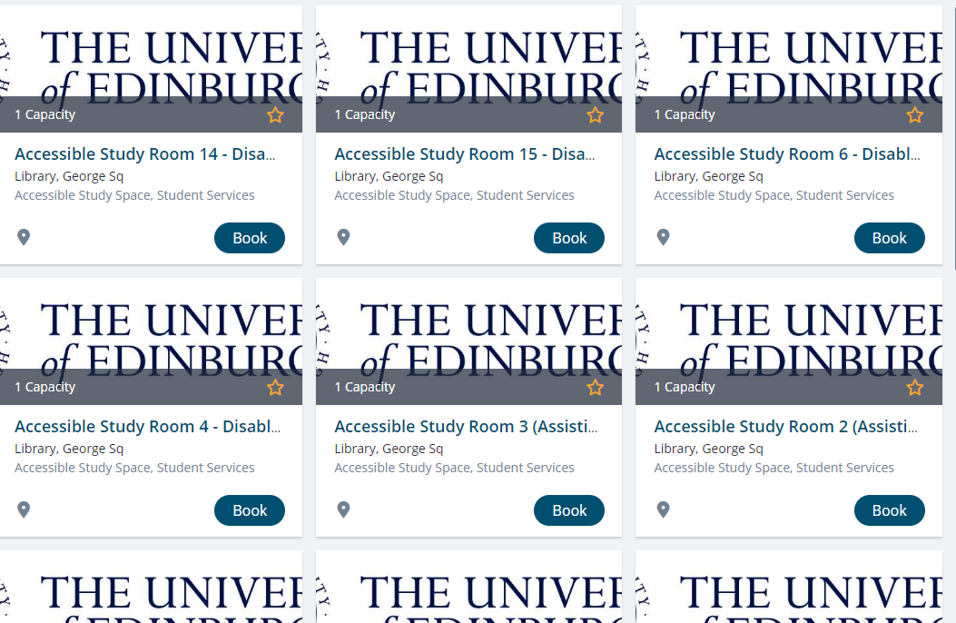

1. Fill in the fields marked with a red asterisk * and then click on ‘**Make Booking’**.

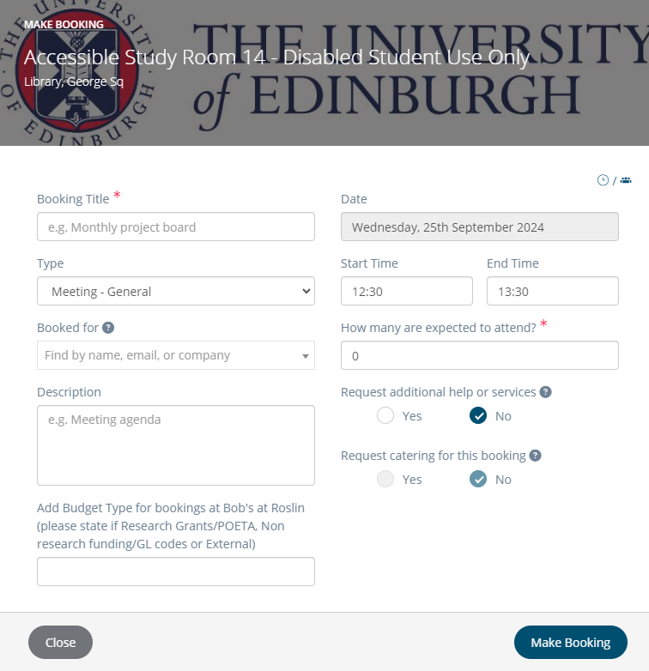

1. You should be able to see your bookings by pressing a ‘**Bookings**’option at the top of the page and then selecting ‘**My Bookings**’.

Example of how a booking will appear:

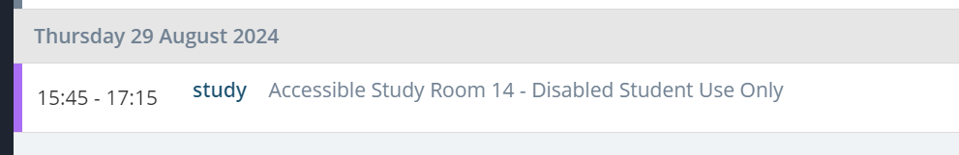

## Cancelling or updating bookings

1. Bookings can be cancelled or edited by clicking ‘**Bookings**’option at the top of the page.
   1. Choose ‘**Cancel** **Booking’** to cancel. Importantly, Bookings can’t be cancelled once the booking has started but they can be ended early to free up the room for another student.

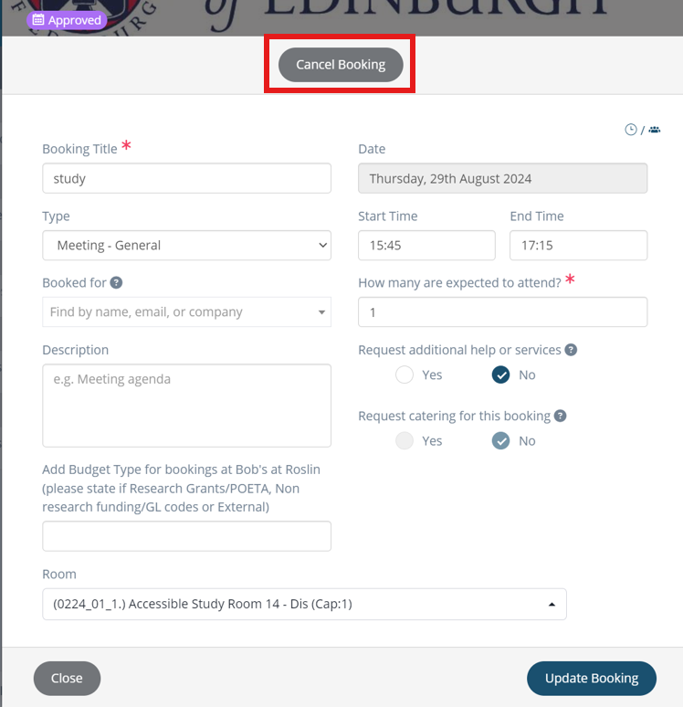

* 1. To change times or end a booking early, amend the Time fields and choose ‘**Update Booking**’.

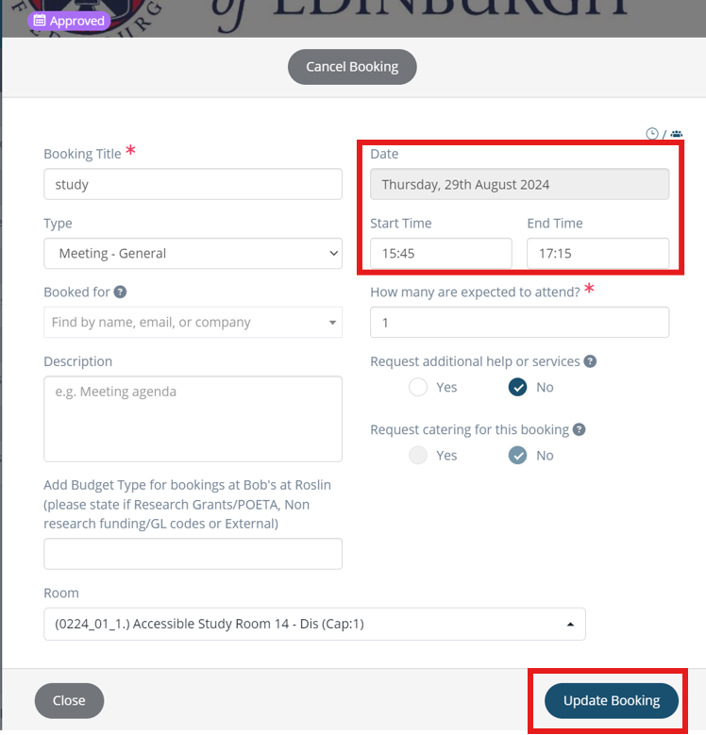

## Booking rooms on a mobile phone

The booking system looks slightly different on mobile phones.

1. Find the ‘**Home**’ page and click on ‘**Search**’.

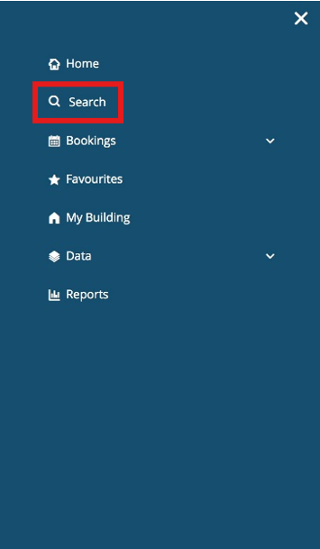

1. There is no drop-down menu, so use the ‘**Search**’box to find ‘**Accessible Study Space**’.

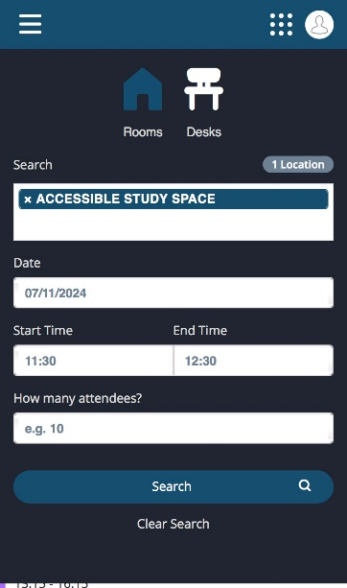

The rest of the booking process is the same as the desktop version.

## Useful information

* Bookings can be made for a maximum session of 4 hours once a day
* If a booking is cancelled or ended early the daily quota (4 hours) is re-adjusted.
* Rooms can be booked 14 days in advance.
* Rooms can be added to **Favourites** (by clicking on the star icon) to make booking easier.

